COMPOST BED
What is composting?
Composting is an environment-friendly way of turning your biodegradable household waste into a beneficial soil amendment. The theory behind the process is that once in the soil, various decomposers start to breakdown the biodegradable waste and if provided the right amount of heat and moisture, the waste gets converted into manure or other useful nutrients. There are many ways of composting including closed-bin composting(fig-1), vermi-composting with the use of worms(fig-2), and bed composting(fig-3), all of which are used depending on the scale at which composting is taking place.
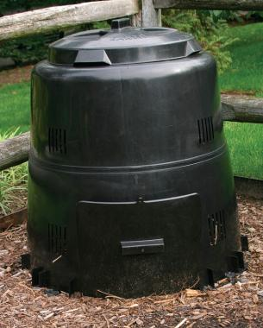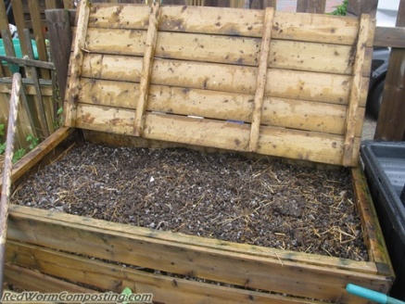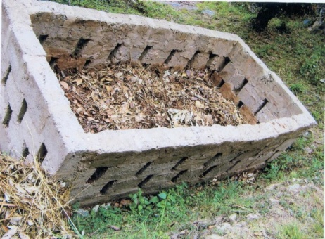
Figure-1 Figure- 2 Figure-3
What is a compost bed?
For a relatively “hassle-free” composting method, compost pits are used in households and in Housing societies to produce manure. The manure bed is built over a soil base for small scale house bins, which needs a cemented structure for more volume of waste. The floor needs to tilt on one side to drain water away and the net-structured bricks of two feet will air it to turn wet waste into manure through air circulation. This waste is then treated with previously made bio culture to fasten the method of composting. This is the method that is going to be used in Mayur Vihar as part of an environment-friendly approach.

Table A: Pros and Cons of Bed-composting
How to make your own compost bed.
Materials Required: Bricks (approx. 50), Suitable plant bed, *Bioculture, Household biodegradable waste, Dead/Dry leaves.
*Bioculture: Mixture of nutrients and biodegradable susbtances that acts as a catalyst for the production of compost.
- FIND a suitable plant bed.
Look for an area with adequate sunlight and moisture and mark a plant bed for the compost-bed with a base of bricks. Make sure that the plant does not have a cemented base. The floor should be tilted a little to make sure that all water is properly drained out.

- CONSTRUCT an enclosed structure.
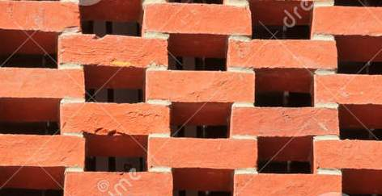
Around the plant, create a permanent structure with bricks to make sure that waste and manure stays in a confined place. The base of the structure should be 3 x 3 sq. ft. and the height should be around 2 ft.
The bricks should be placed in a net-like structure(as shown in diagram) to allow air to pass through the compost.

- SEGREGATE your waste.
Before putting any waste into the bed, segregate all the non-biodegradable substances such as paper, plastic, metal and chemicals. *Only the biodegradable waste should be put into the bed (dead leaves, kitchen waste i.e. leftover food, fruit peels).

- PLACE the waste in the compost-bed & cover it with bioculture.
First throw in all the biodegradable wastes into the bed and then sprinkle a layer of bioculture on the top.

- COVER the pile made with dead/dry leaves.
Make sure that the pile of waste plus bioculture is completely covered with dead/driead leaves on the top.
And finally,
- GIVE your bed time and effort.
Do look after your compost-bed regularly and take care of it, and gradually, your effort will pay off and give you results!

