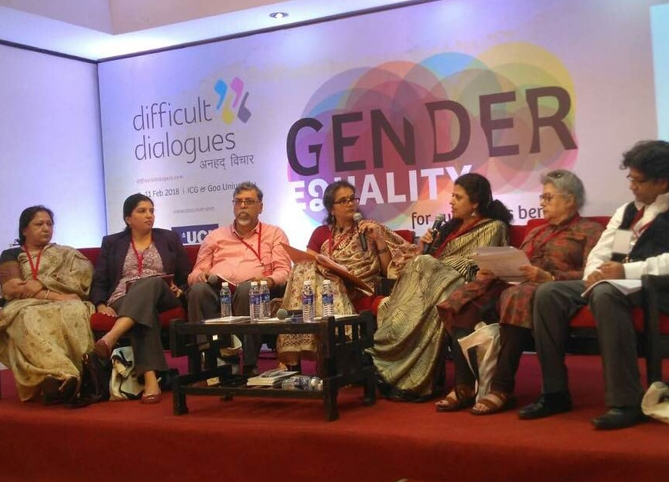
SAFP Annual Report 2017-2018


Content |  |  |  | Page
Chapter 1 |  | Introduction | 2
Chapter 2 |  | Partnering on work with vulnerable communities |  |  | 3
Chapter 3 |  | Research Activities |  |  | 7
Chapter 4 |  | Awareness, trainings and policy impact |  |  | 9
Chapter 5 |  | SAFP collaborators and people |  |  | 14
E09, Anand Lok, Mayur Vihar Phase I
New Delhi 1100091 India
Contact: 00 91 11 22756014 email: safp.sb@gmail.com │ www.sathiallforpartnerships.org

[ A registered organization since 2004 with FCRA.]

Annual Report SAFP 2017-2018
Chapter 1 Introduction

The vision of work for SAFP this year was to develop safeguarding programming for vulnerable children and adults. The groups that were chosen as work for the next five years were children and women who had been abandoned by families, communities who were living in last mile villages and those who were excluded or were under the threat of exclusion due to law or programme change.

As can be evidenced in this annual report, SAFP made an impact this year by working on non-formal partnerships. The organization won only one funded research project and that too had to be handed over to Jamia Millia Islamia as the Government would give research grants to academic institutions and not NGOs. This infact became a strength in disguise as SAFP got access to resources as well as a wider range of personnel to work with.

It is heartening that the whole year SAFP team has worked on the organizational goals completely on a voluntary basis.

November 15 2017 SAFP strategy meeting at the Habitat Centre Delhi :

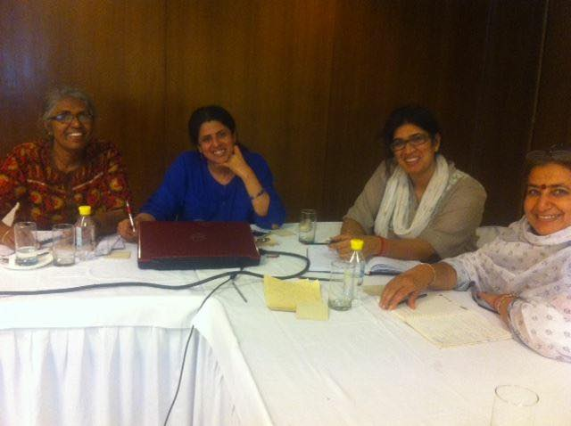
A revisiting of vision and mission was undertaken by SAFP team to streamline work of the organization this year. At a revisioning exercise held at Habitat Centre the programme development team listed thematic work to be based with specific vulnerable groups of people and planned a time line towards the same. The programme staff were advised to take up independent work as consultants as paid work within the organization was planned not to be undertaken for the next five years. Advisors for SAFP were appointed this year who committed to raise resources for specific projects that will build capacity of partners in thematic programming skills SAFP team had. All advisors were stationed outside of India. The effort was not only to raise funding but also begin SAFP International in five years.

Chapter 2 : Partnering on work with vulnerable communities

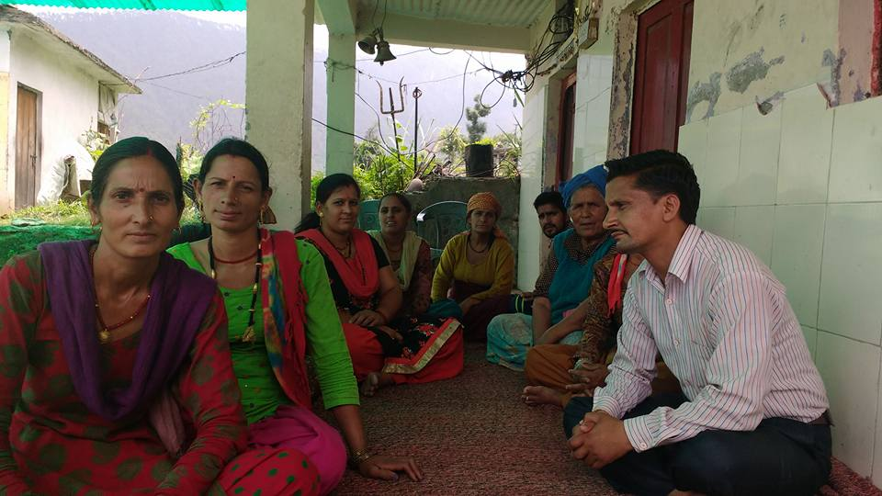
Hill Village Population SAFP partnered with Green Assets.in to reach solar energy and water to Uttarkashi district in July 2017. Green Assets https://www.greenassets.in/csr is a private limited company that promotes sustainable living in last mile villages as well as in cities. SAFP took on its adapt a village programme to develop their CSR collaborations. Towards this end a three year process has been agreed upon wherein SAFP has a role in linking Greenassets.in with Village level groups beneficiaries such that companies could adopt village group to support them under the CSR portfolio. From April 2017 to July 2017 SAFP met with village groups and their leadership to conduct a need assessment. The villages visited were Kimoda in Chamoli and Paul Gaon in Barkot, Multadi in Purola, Pajuli in Mori that were in Uttarkashi district. The women trained under Mahila Samakhya were reached to understand if they could develop a system demands to propose green enterprises. These enterprises were setting up wind - solar battery charging units, bio toilets and training of women self help groups in sustainable asset management. The groups were then linked with the CSR department of ONGC limited and UNDP office in Dehradun Uttrakhand.

Families that have had a Mental health issue

25-26th November 2017 at workshop on "Creating Better Recognition and Support for Family Carers" IBHAS, Delhi.

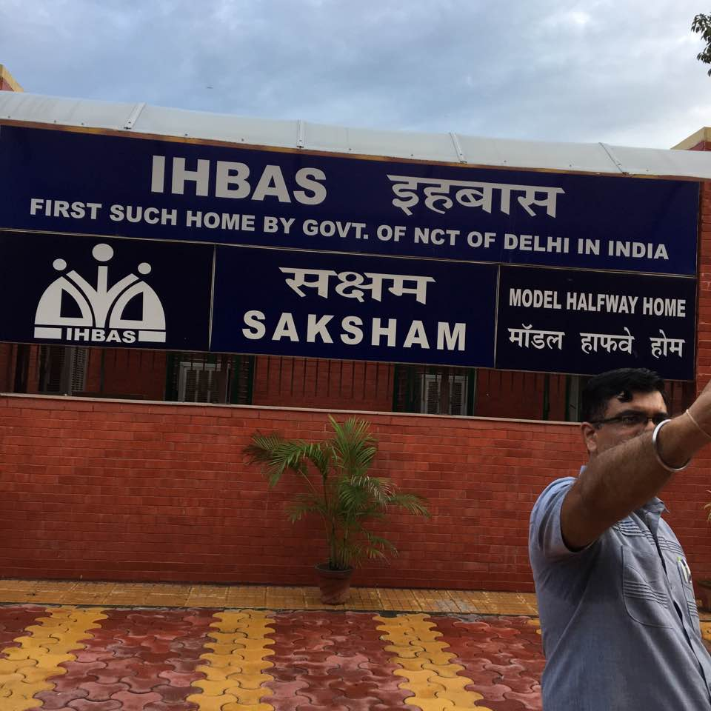
Mental Health remained a dedicated focus of SAFP in this year as well. The monthly clubhouse activities were held at member homes furthering the agenda of wellness in each meeting through music and art. Members met to acknowledge each other as strong resilient people who engage in creating wellness when the going got tough. Members continued to suggest exercises to each other and provide a listening ear to those who have the courage for sharing of life experiences. The counselling services That were affiliated to SAFP this year were the Banyan Tree and Listen in. Three medical practitioners participated in the SAFP mental wellbeing programme of these two regularly supported the clubhouse members in their psychiatric treatment while one of them looked into disorders due to gynaecologist issues. The recovery from remission phase for those suffering with mental health problems was reported to be the highest this year.

Two day workshop on "Creating Better Recognition and Support for Family Carers" was held on 25-26th November 2017 at IBHAS, Delhi. SAFP actively participated in the workshop with Deepika Nair Executive Director SAFP who provided inputs from the community of support groups on mental health. Insights were shared by Ms Pranjali Malhotra on the SAFP clubhouse interactions in the community on need for developing a stronger care narrative in mental health. SAFP submitted suggestions Delhi government disability department and policy makers for introduction of identify cards to carers, to help them avail facilities. That these recommendations were valid was evidenced by the endorsements given by the participants to SAFP recommendations. The recommendations given by SAFP were well taken. The government representatives gave SAFP assurance for its inclusion in the way forward agenda of the official committee working in the disability department.

You me and mental health, is an India International Centre initiative taken along with an NGO called Anhad. This initiative involved SAFP in serval rounds of discussions around mental health. Topics ranged from types of mental disorders, rehabilitation needs, support for carers, homelessness and managing relationships. Community mental health and public engagement around de stigmatization of mental health is one of the prime areas of concern for SAFP. Team participated and contributed regularly in this to support and strengthen the cause of mental wellness through the year.

Individuals living in Alternative Care : SAFP supported work to develop the discourse on care of individuals living outside the purview of family. This included children as well as adults. SAFP supported three associates during the year to work with 1) Widows who live in ashrams 2) Those youth who have had no parents and 3) Elderly who have lost support from family. These associates were trained by the SAFP with regular mentoring sessions and guidance to participate in public events to put forth the need for care and inclusion in daily living as well as in policies of the state.

Children in Alternative Care:

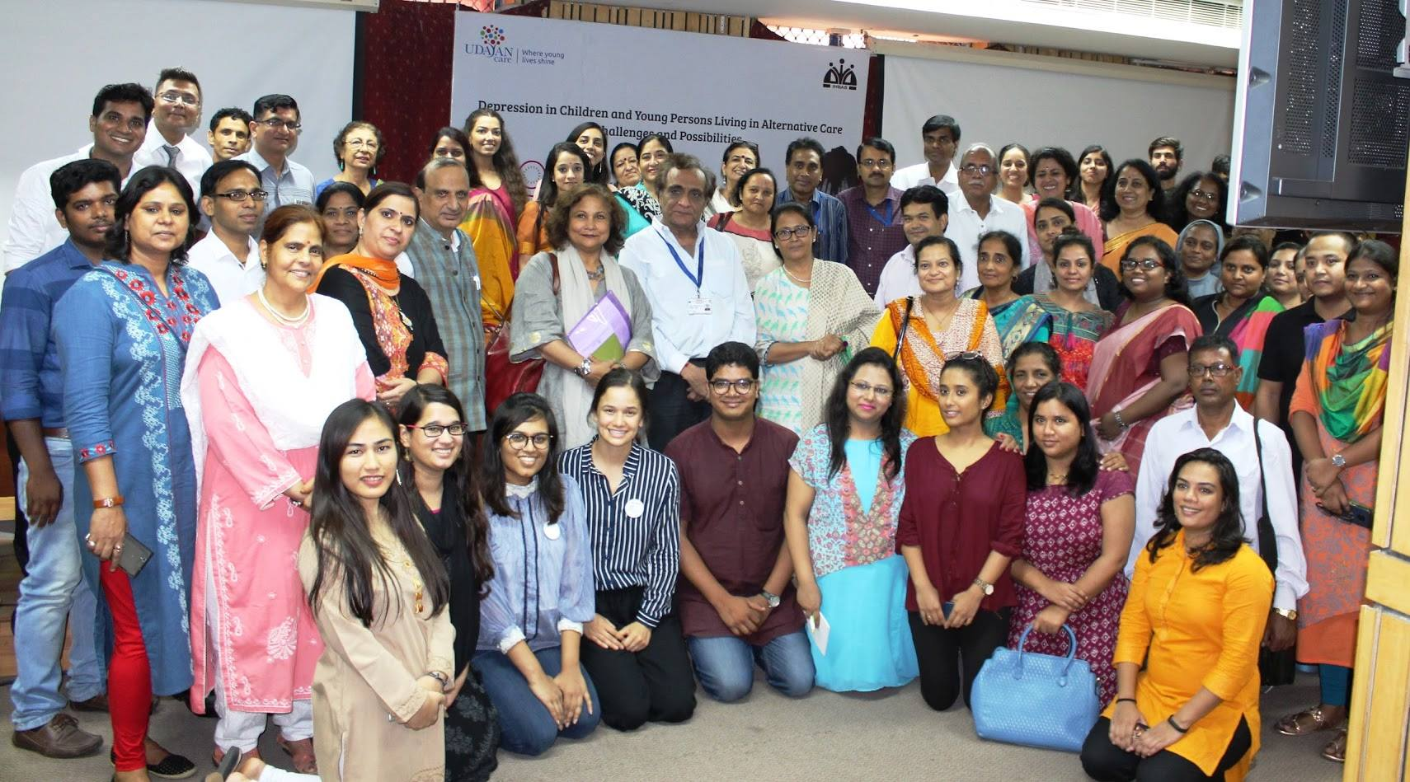
September 1, 2017 Depression in children and young persons living in alternative care was a one day consultation held at Institute of Human Behaviour and Allied Sciences (IBHAS), Delhi. Ms Pranjali Malhotra attended this programme on behalf of SAFP.

Experts, practitioners as well as children who had grown up in alternative care attended this workshop. Interestingly for SAFP founder this was a day she began working as a Senior Consultant with Udayan Care to develop their Aftercare Outreach Programme on this day. The day is historic as it began a new journey for SAFP learning about life of children and youth in institutional care.

Soon after the workshop Mr Imran Khan Hosseini was appointed as a whistle-blower for reporting cases the issue of child abuse and depression among children and young persons. During the year 8 cases were reported and resolved. These cases were reported by youth who came to SAFP affiliate centre called Adharshila. This centre managed by Mr. Khan. Adharshila has a membership of children who live in and around Pandav Nagar and Lukshmi Nagar.

Women in alternative care:
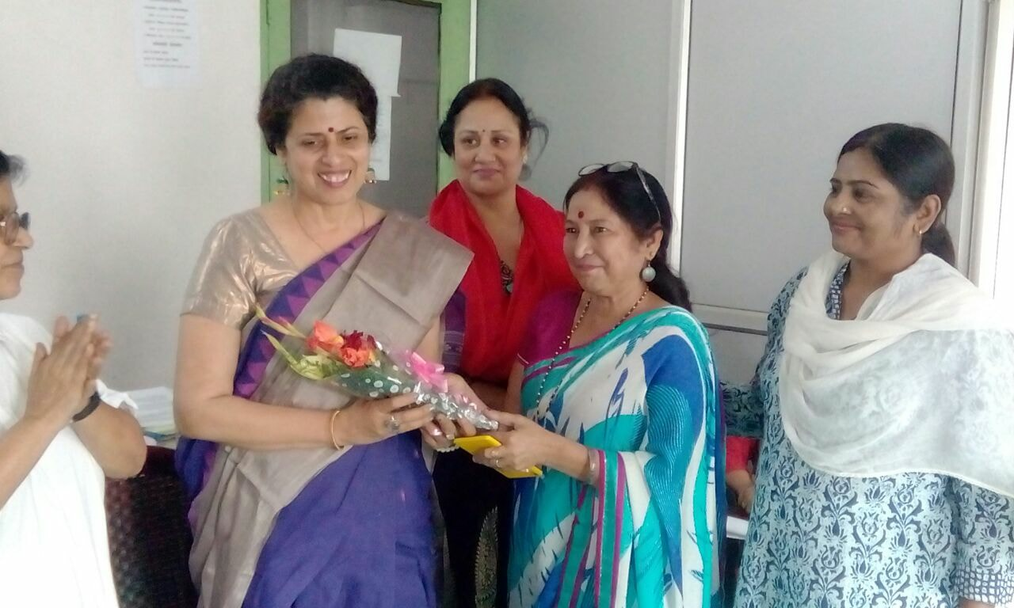
Widows of Vrindavan need to assert their right to resources and spaces. They have beenn thrown out of their homes as they did not have any space to remain with their marital families once husband died. Living a life of destitution at the behest of patriarchy and being at the receiving end of doles handed out by charitable institutions has led them to violation of their dignity. A consultation was organised by Ms Rakhee Gupta who has been a mentee of SAFP for work on women empowerment. Rakhee has understood the women and resource increase agenda promoted by SAFP and has agreed to associate with the organsation with the plan of working with specific group of women. Dr Shivani Bhadwaj was consulted to stratergise on women resource increse agenda for widows of Vrindvan. Ms Rakhee Gupta then travelled to Vrindvan to document case studies of widows to understand what they have been able to garner as support from local , district and state admistration. As expected the widows have had a very raw deal. They asked Ms Gupta to raise concerns at local level and then got their issues to advocate them in Delhi to gather support toards their resourcelessness.

A seminal meeting was organised in the last week of October at ITO in the Child line office where Dr Bhardwaj was requested the chair the morning session. The programme was organised by Swatch with voluntary contributions of other oganisations . This as a welcome innitiataion as such that a non funded collaborative process began to support a constituency that has no one to turn to for support.

Work with Unorganized Sector Workers

Work with waste workers
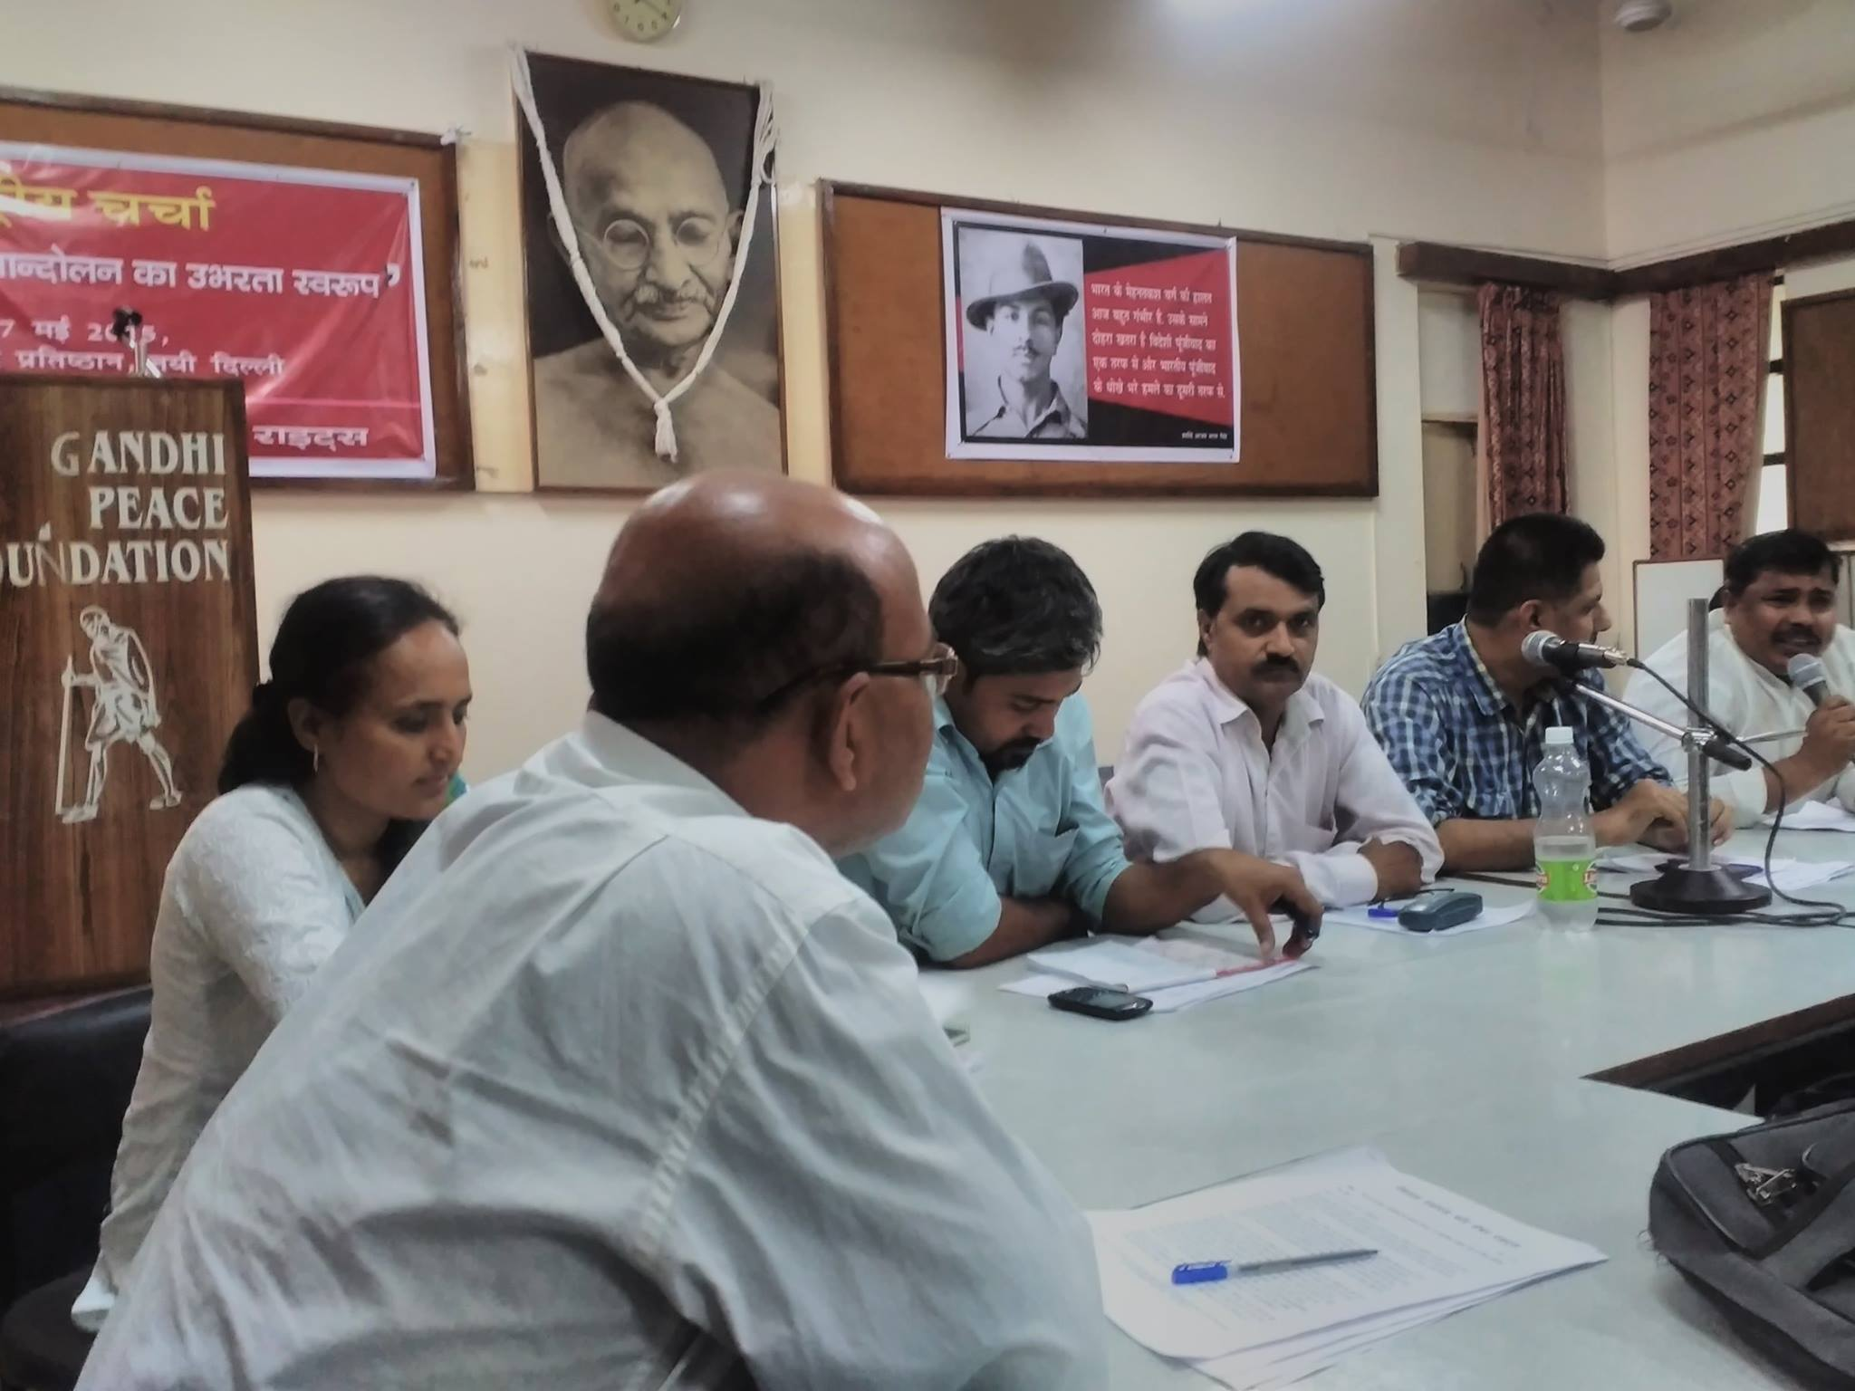
SAFP journey of work with waste workers and its support from Fund For Global Human Rights( FGHR) was concluded this year. FGHR provided support to SAFP unorganized sector workers work with different awareness programmes that SAFP participated in. This awareness programme was anchored by Mr Shashi Bhushan who led to workers in the state of Bihar, Delhi as well as in a few pockets of NCR and UP. Mr Bhushan has set up a workers platform called All India Kabadi Mazdoor Morcha (AIKMM). This platform as set up at a crucial juncture as the new waste management rules were introduced in April 2016 to promote corporatization of waste sector and in visibalization of waste workers. AIKMM and its partner organizations held a national and several local meetings during the year. In Mayur Vihar Mr Shashi Bhushan worked with the organization called Centre For Development of Technology. Dr Sneh Mohan as the convener of CDT and the member of the Residents Welfare Associations of Mayur Vihar was instrumental in moving the local and the district administration to make provision for segregating the wet waste from dry. Place for making compost out of wet household waste was allocated in different areas in East Delhi District to increase awareness about hazards faced by waste workers.

National Alliance For Labor Rights (NALR) meeting at Gandhi Peace Foundation (GPF) : SAFP is one of the founding members of the NALR. Through this year meetings of the members of the NALR were held in different parts of the country. The gatherings albeit were small as these meeting were largely local and sector specific. The labor day awareness programmes were also held in a decentralized way and were reported between the membership through informal communications like whats app. Email reporting has considerably dwindled as change in ways of communication have taken place. None the less like every year a national meeting of NALR was organized on May Day at the Gandhi Peace Foundation that got together the different groups face to face with each other. Shaheed Bhagat Singh Jayanti was celebrated in September at Gandhi Peace Foundation where different groups reconvened to discuss their process of organizing themselves and aligning to NALR.

Eduseva Scholarship Programme :

The Eduseva scholarship programme continued to support students from vulnerable backgrounds to pay for their tuition fee from graduation courses. The range of scholars who were supported this year had a number of students from humanities background as compared to past few years where students. Mr Jitender Dutta who funds the Eduseva scholarship programme could not meet SAFP personnel as many times as previous years. Yet SAFP opened the discussion on how the Eduseva scholars could to think of ways to sustain the scholarship after Mr Dutta ceases to support this initiative. The scholars made proposals over the course of this year next few years. One of the ideas that a scholar posted on the Eduseva whats app group was that each Eduseva scholar pledge 20 % of their salary once they begin earning.
Through the year Eduseva scholars were contacted for different SAFP and other Civil Society Organization events. The focus of these events was how can each scholar change their current behavior to raise resources with CSR and individual funds to continue to support needy students with fee for the course of their choice and hostel fee.

Chapter 3 Research activities

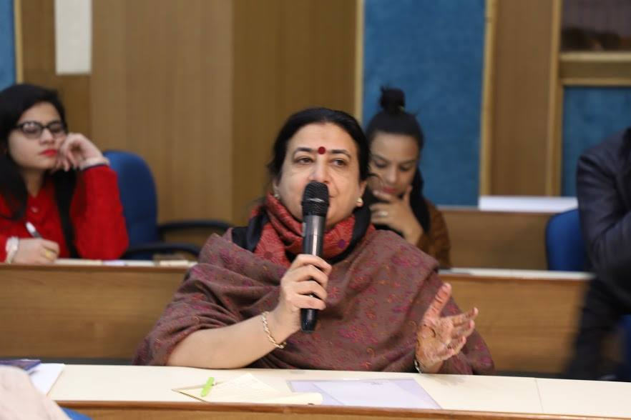
Project : Status of middle age Women : In the previous year SAFP team had developed the research proposal for Middle aged women's psychosocial wellbeing in Delhi NCR. This was approved by the Ministry of Women and Child Development in September 2017. The ministry had revised its rules according to which the proposals for research were to be awarded to research and academic institutions alone. This in fact was a very welcome move for SAFP as much more is required to engage the academia to concerns held high by civil society discourse. SAFP approached the Director of different centres in academic institutions. The middle age women was not a priority for may agencies. However, this was of high interest for the Sarojini Naidu Centre for Women's studies of the Jamia Millia Islamia (JMI). The arrangement however was that SAFP proposal became JMI proposal. The proposal was submitted afresh by JMI and this research was solely undertaken by Sarojini Naidu Centre for Women's studies, JMI. SAFP staff appeared for interviews for the research coordinators position and was enrolled as a research contractual staff member of JMI for the project. On the periphery Safp helped in organizing focus group discussions with women groups, facilitated group meetings through its clubhouse members and provided consultation for the execution, analysis and report writing of the research study. The study spread over a period of 15 months beginning from November 2017. The research focussed on development of tools, hiring and training staff members such that the data collection process for the research could commence. The staff underwent training in videography of some of the interviews that were documented after filling in consent forms of the respondents.

Advisory Role in Udayan Care research on status of Youth leaving Care in India:

Udayan Care had developed a research design to study the status of Youth Leaving Care (YLC) in six states of India with help of Tata Trusts and UNICEF. SAFP Executive Director was invited to be on the advisory committee of this research. She attended the inception workshop for the research based on her extensive experience of working with Save the children as well as SOS children. Safeguarding the life of YLC however is a specialised field and in most part it needs greater participation of children and youth in the research. The research that SAFP was advising on however did not include the participation of the constituency as Udayan Care was conducting research by its own self for the first time. The agency appointed specialist to produce turn key ideas that were revised and redrafted several times by different authors. Advisory committee was called upon when it was required to be seen as a process that was guided by non partisan approach. However in the process SAFP learned much.

Research on the inheritance rights of the wards of the state : SAFP conducted seminal research on the issue of inheritance rights of the children who have lived under the guardianship of the state through the year. The Child Care Institutions (CCI) in India are regulated by the government as it is the duty of the State as a signatory of the UN CRC to ensure the survival, protection and development of vulnerable children. These wards of the state are entitled to a child development and an aftercare plan before attaining the age of 18, as Care Leavers (CL) are required by Juvenile Justice Act 2015 (JJA) leave the care home by 18. CCI have been offering Aftercare as their moral obligation towards children they have looked after but legal binding for not providing aftercare has not been enforced by any stakeholder as yet. These CCIs are making ends meet to provide for the children. They get donors to build accommodation and hostels for children and youth. This infrastructure belongs to the CCI and the child or the youth has no right over the property of the CCI. The state and the central governments too similarly use the tax payers money and the revenue it generates from infrastructure for governance. Much of this public property has been wrongly taken into private ownership. The seat of the highest position of authority in India has also abused its positional power to take away state resources. The wards of the state could be socialised and trained in a way this can be put to a stop. SAFP while working with CCIs realised that an agency outside current stakeholders needs to take on this call as people who have a stake will never be able to raise this as an issue.

Consultation on Aftercare Programme in Delhi December 14, 2017 at Habitat Centre Organised by Udayan Care and DWCD.

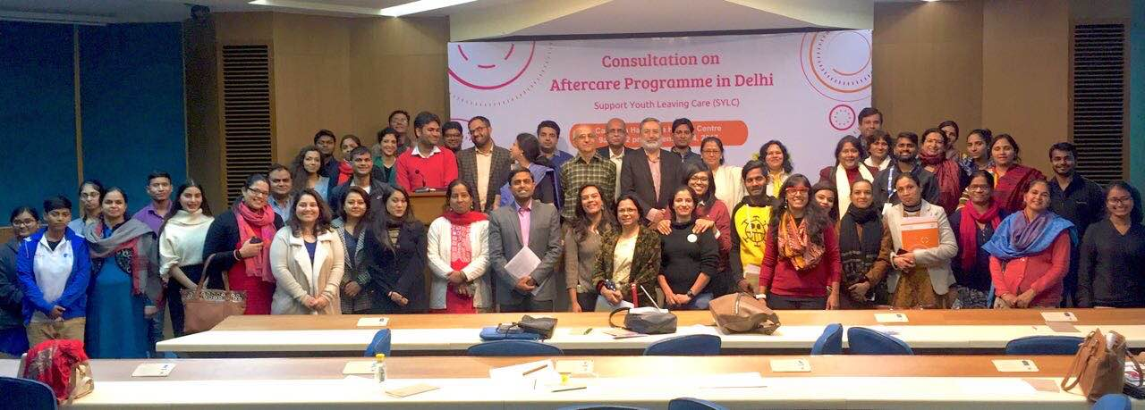
The Department of Women and Child Delhi Government was enrolled by Udyan Care to own upto its responsibilities towards aftercare. A This consolation was organised to get the stakeholders together to discuss the issues as understood by the Care leavers, The government and CCIs and the legal community which were to study the gap between what was provisioned and what can be demanded as a matter of right by the YLC towards aftercare as a right. Ms Pranjali Malhotra of SAFP attended this consultation as a stakeholder active on youth and development in Delhi. Ms Malhotra has experience of work on sexual abuse and counselling. During the consultation she met with several YLC to connect to them after the consultation. One of the person she met was Mr Aditya Yatri who is an Alumina of SOS in Maharashtra.

Research to advocate for the rights of the YLCs in India
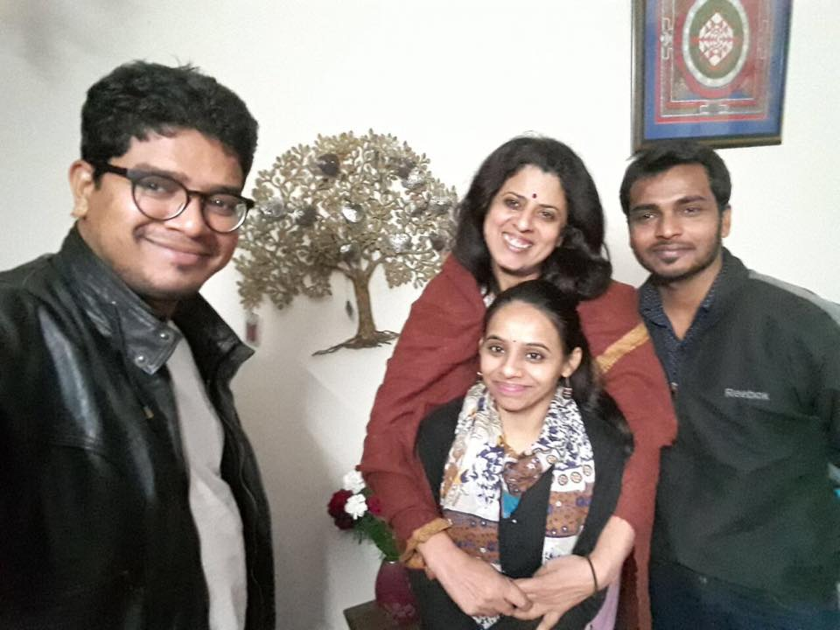
Mr Aditya Yatri on his return from Delhi set up a forum of Youth Leaving Care Association. He has since then been in constant touch with SAFP for mentorship on how to develop the association to be a strong advocate for the rights of the aftercare youth in India. SAFP has assisted Mr Yatri to research on issues faced by the Youth leaving care in India. Mr Yatri is in the process of completing his PhD on the subject. He has been invited to most of the consultations organised by Government and non government agencies on aftercare. The government representatives consult Mr Yatri on developing programmatic guidelines of aftercare. Mr Yatri has regularly sent advocacy drafts and articles to SAFP before submitting the same to the government and non government stakeholders.

Chapter 4 Awareness events, Trainings and Policy Impact

25 July 2017 SAFP Training for the Vishwa Yuvak Kendra (VYK) in Delhi.

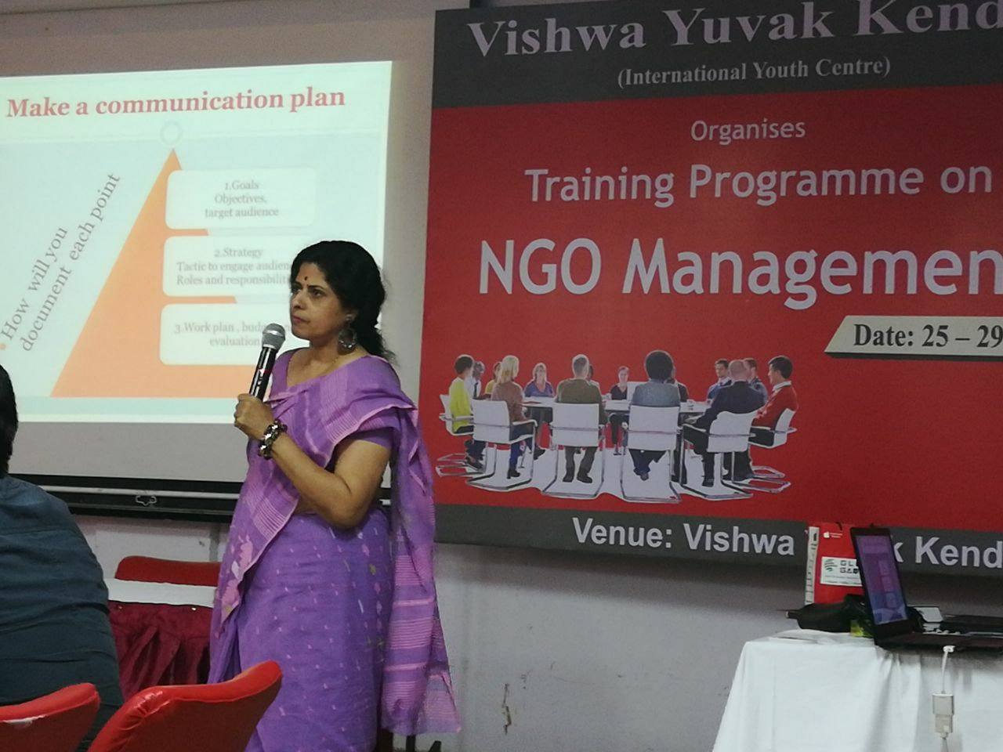
SAFP was invited to train NGO personnel at VYK. The motivation of these personnel to work for social development got reaffirmed after the training they received. The input provided by SAFP was on developing the communication skills on advocacy. Issue based advocacy has a limited life. The social development goals of each organization has to be clarified first and foremost. A communication plan needs to be developed after a process of research and consultations. SAFP activities in training are based on its research and analysis.

Trainings SAFP conducts has element of advocacy for specific policy impact. Most of SAFP interventions are supported by Consult For Women and Land Rights (CWLR) members globally, with local groups who provide inputs on real life experiences. SAFP is also a member of Habitat International Coalition and High Level Planning on Gender equality this its international networking assists work at grass roots for intervention to asking think tanks to provide academic input to queries across different regions of the globe. SAFP has been able to do this by engaging with the development world as an organization and as SAFP members engaging with chosen assignments as independent consultants.

In India this year SAFP completed a consultancy with UNICEF wherein it advised the office in the state of Assam on a strategy that it should adopt to realize right of the child in the state. SAFP presented the strategy to UNICEF Assam at a staff meeting in Guwahati. The experience of this consultancy enables SAFP in situating the ideas around what state governments could do to realize Child rights within the governance structure. SAFP advocacy training began in 2003 and has led to behavior and social change, as women and youth have started to claim resources and use them to improve their livelihood and life of their community. SAFP events and publication have demonstrated the improvement in the resource base of children, women, Dalit and Indigenous communities. SAFP and advocacy and training manuals and research have been used in district planning and sector based work by the authorities in 4 countries.

Sustainable Development Goals (SDG) :

SAFP has engaged with SDG indicator development for the Goal 5 at national and international levels. Towards this its representatives have attended several for meeting through the year. The invitation of SAFP is grounded in its experience of work in gender equality and its advocacy to address the gender resource gap with specific measures that are rooted in in gender equality planning. For example SAFP representatives were invited to the Consultation on the National Indicators for the SDGs Implementation, being organised by Beyond Copenhagen and other CSOs at Delhi on 6th April, 2017 at Lecture Hall No. 2, IIC Annexe. After deliberations inputs were provided on a google document having SDGs Goals and Targets, on global and national Indicators. Another example is SAFPs participation at the Impact Conclave on the 30th and 31st August 2017 at The Lalit in New Delhi. was Conceptualized around SDGs, the event fixed its spotlight on the intersection of three concepts- i.e. Idea, Insight and Impact, which form a perpetual interlace where one is inconsequential without the other. The convention attempted to capture the essence of this concept by discoursing, consolidating and sharing best practices and lessons while offering a dynamic and flexible platform for new thinking, ideas and advancements still to come. SAFP participated actively and gave its inputs for creating a convergence approach for achieving SDGs specially in context to goal 5.

Based on the input provided to different agencies, SAFP developed a detailed proposal on impacting the Gender the gender Resource Gap to realise SGD gaol 5 and this was submitted to MWCD.

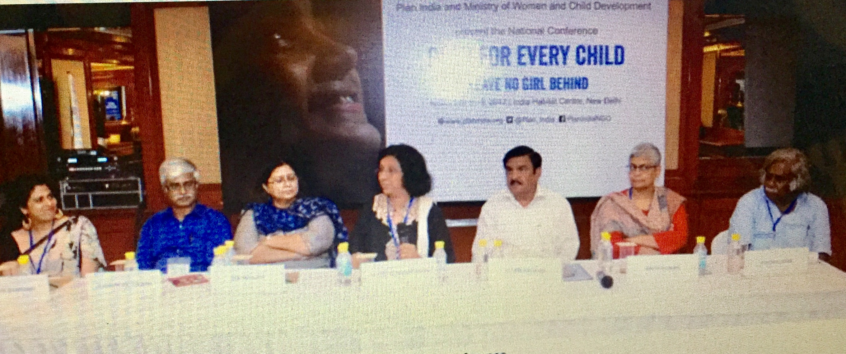
Research for policy impact on the girl labor in India: Plan For every child was a four day conference organized by Plan International at Habitat Centre Delhi where SAFP was invited to present issues around forced girl child labor on November2, 2017. The chair at the session shared a startling violation where on pretext of treating menstrual cramps a fertility clinic was duping innocent unaware girls by harvesting their eggs without telling them. SAFP advocated for sensitive planning to bridge the gender resource gap which has been a fulcrum of SAFP work. The girl in forced labor can be any one those doing unpaid housework, bonded labor, sex trafficked, begging or participating in home based work. The girls are made to drop school, and meagre or no wages. gave a call to work doubly hard to create peaceful satisfaction of enjoyment of what life and nature gives. Getting to a life of collaboration and cooperation sooner to leave competition and consumerism behind is not that difficult. The Government has amended child labor laws to assist families to make children work when they turn 14. This move has impacted girls education adversely.

Training on women and property rights On February 2, 2018

SAFP was invited to train students of Kalandi College to understand their right to property. The summary of the input is shared as under
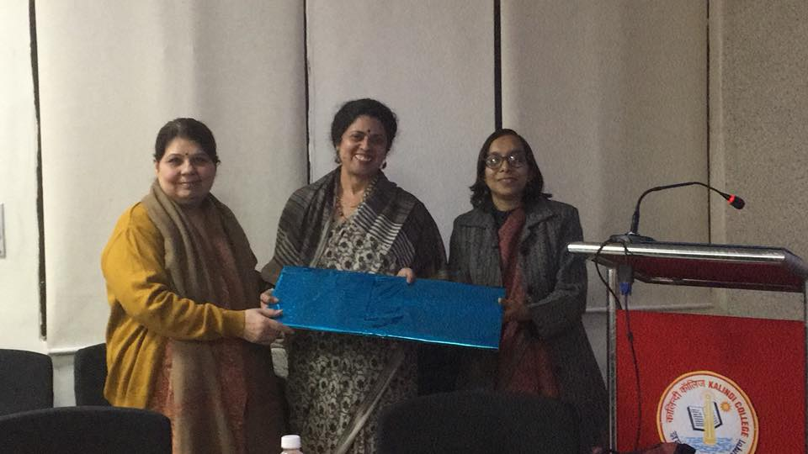
Despite the national amendments to property laws and claims of gender equality in inheritance, there is need to differentiate women’s right to land, in her capacity as an equal citizen. Young students were very aware that there is an association of ownership and control of resources (mainly land and housing) with a sense of empowerment that lends security. This is perhaps because the Kalindi college has a Faculty that keeps students aware. SAFP association with the college has been through Dr Anita Tagore who is a CWLR member since its inception. She had already informed the students that each citizen has to be aware about the interrelated laws from a gender perspective.

Individual property rights are as provided by the religion of the parent and these then are further governed as per state laws that are different in different states of India. Thus each person has a particular situation and a personal context of ownership of property they own and will it to those who can inherit it. Property rights for women in In India are operationalized with more difficulty than men. The trans gender have even less as they are largely dispossessed. No state in India provides for a single legal model that can get them to fulfill the constitutional obligation for gender parity in property holding. Goa which as the most liberal in granting women their property rights too has less property in women’s names. Gujarat widows have been able to claim this right more than women who never married or were divorced. Women in Mizoram and Jharkhand have been denied equal property rights at the primacy given to customary tribal traditions, while in Sikkim, Jammu and Kashmir, a woman who marries a non-state subject, loses the right will her children inherit her property. Even if she buys property in her own name, it will be relinquished to the State after her death.

Research has also shown that irrigated and dry land ownership is more related to culture and geography than to socio-economic development. Even if women on the ground are aware of their legal rights relating to inheritance or about government resolutions on joint ownership of the house by both husband and wife, its registered is still difficult as members in families and registration offices are unaware and nonaccepting due to cultural and patriarchal traditions. Women agriculturalists and workers may work on the field each day of their lives but very few of them own land and they are thus excluded to take benefit of government programmes and services. SAFP has worked with women farmers and widows who are reported to be highest in the in census data of adult women. Indian adult women survive longer than men and for this reason they must have effective control of some property, either in the form of land or an ancestral home for decent survival.

Chapter 5 SAFP Collaborators and people

SAFP Board of Trustees 2017-2018

President : Dr Vinay Bhardwaj
Program Director : Ms Sharmila Mahajhan
Founder and Managing Trustee : Dr Shivani Bhardwaj
Member Trustee : Ms Manu Tyagi Baijwan

SAFP Staff Members

Executive Director: Ms. Deepika Nair
Waste Workers Programme: Mr. Shashi Bhushan Pandit, Mr. Brijesh Gopalan and Ms. Mansi Singh
HUM SATHI Programme for wellbeing : Ms. Pranjali Malhotra

SAFP Programme Associates

Ms Aditi Sabharwal
Mr Imran Khan
Ms Rakhee Gupta
Mr Aditya Yatri

Collaboration with Partners : Nirmana, CDT, Greenassets.in, Aadharshila and Sach.

******

