SAFP Annual Report 2018-2019
Content |  |  |  | Page
 | Executive Summary
Chapter 1 |  | Introduction | 1
Chapter 2 |  | Partnering on work with vulnerable communities |  |  | 3
Chapter 3 |  | Research Activities |  |  | 7
Chapter 4 |  | Awareness, trainings and policy impact |  |  | 9
Chapter 5 |  | SAFP collaborators and people |  |  | 14



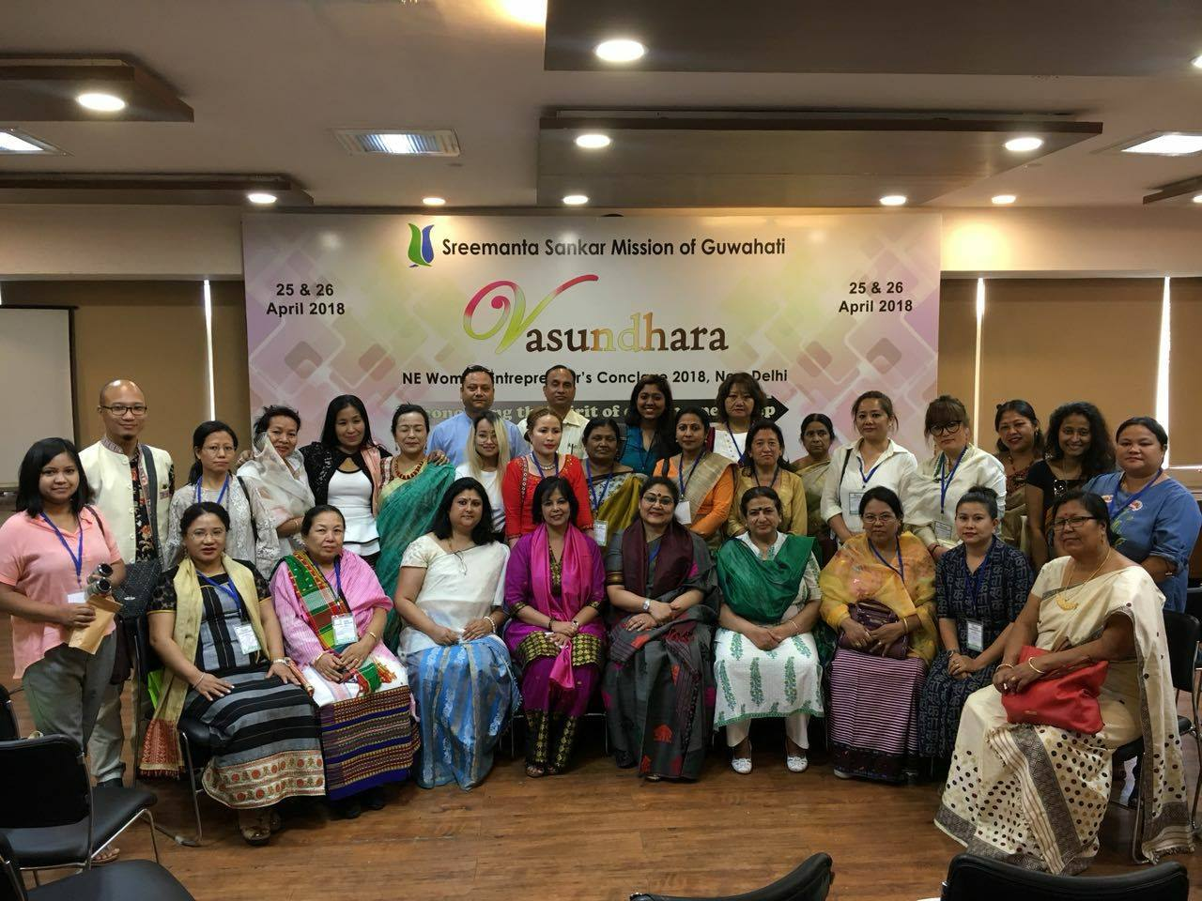

E09, Anand Lok, Mayur Vihar Phase I New Delhi 1100091 India
Contact: 00 91 11 22756014 email: safp.sb@gmail.com │ www.sathiallforpartnerships.org

[ Sathi All For Parnerships is a registered organization since 2004 with FCRA. Its Darpan ID is ]

Annual Report SAFP 2018-2019
Chapter 1 Introduction

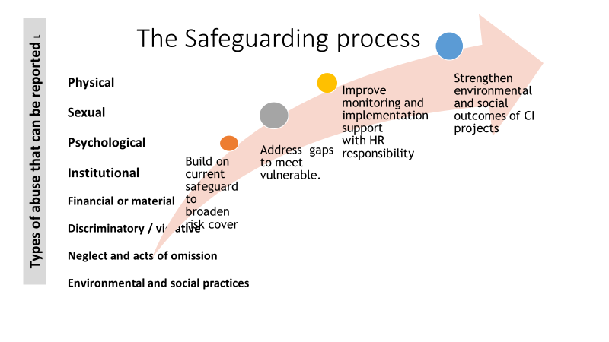
This year SAFP and its partner organizations focused on research and development to realign its goals to focus on safeguarding principles and techniques to help vulnerable groups it supports. The groups that SAFP choose to work with were women, youth and workers.

The mental health portfolio of SAFP continued this year to acknowledge the role of non-specialist health care providers who need to be trained to identify and support psychiatric morbidity in the community. To plan this process SAFP team met in Goa on 9th August and then travelled to its Kerala office in this year.

The year was invested in researching on the kinds of abuse faced by the excluded such that focus areas of intervention could be ascertained. It was found that women in general were excluded from the market and to address abuse in this sector SAFP worked with women entrepreneurs to advocate the setting up of a national women enterprises council. Work with widows continued and this spilled over to women and girls who have under institutional care through out India. Engagement with aftercare of Youth Leaving Care (YLC) continued and it took off on a certain pathway from February 2019 when SAFP approached different CCIs to strengthen their support to youth that have lived with them.

As a new initiative SAFP collaborated with Indian Aces to define and organize awareness campaign on Asexuality with support from Planet Romeo-Foundation. Preparatory work was completed this year for workshop roll out in the next year.

This year also saw the development of SAFP legacy support programme. While the 80th birthday of three women movement leaders in Delhi celebrated this year, the issue of wither legacy of those who contributed towards the strengthening the women's movement in India cropped up. In their twilight phase they are going about strongly working, even as their contribution already has huge value. Some have begun to use a support system and others win their independence sans support defying age. Some of the pioneers are now immortalized in our mind as they Rest In Peace. These mentors and innovators will live on through those who have learnt from their work. Women movement leader’s legacy needs to be nurtured as much as the legacy of others who carry forward the value created by the predecessors. However, names of just a very few women leaders is documented at present. Contribution of women who shaped thinking on equal rights, capabilities/skills, body politics and inheritance need to be recognized. The first in the series of legacy development work was chosen to Ms Rajni Tilak who passed away last year.

Chapter 2 : Partnering on work with vulnerable communities

Work with Women in Distress

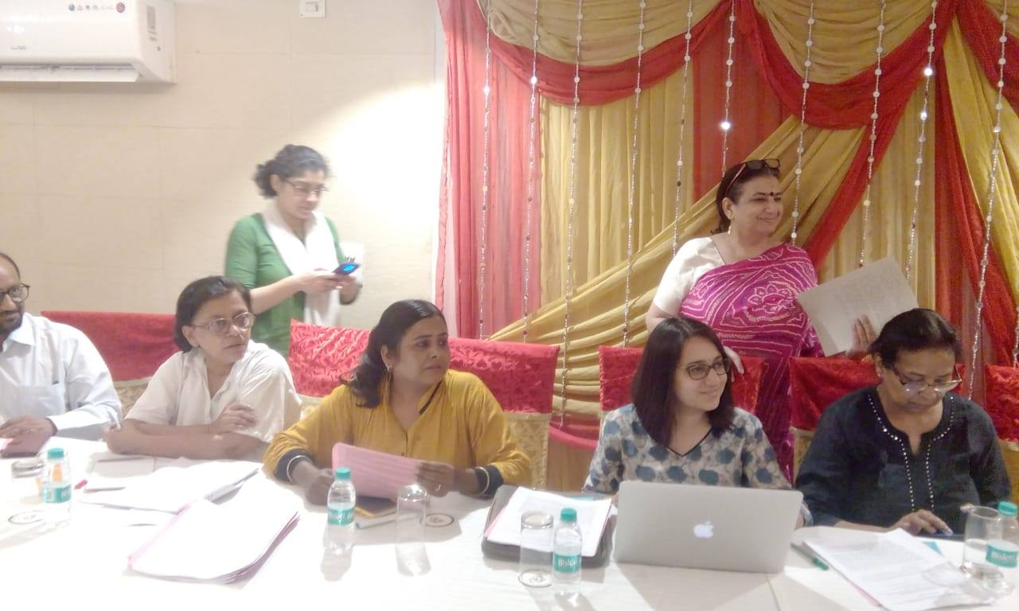
June 14, 2018 Consultation on follow up of Supreme Court order on Widows of Vrindavan and all women in distress : A consultation was held for Improving situation of widows of Vrindavan on the challenges of implementation and monitoring of the order of the Supreme Court dated 11 August 2017 at the JRD Luxury Boutique Hotel, Safdarjung Enclave, New Delhi. The Conveners of this consultation were SAFP – Sathi AllFor Partnerships, Bhartiye Jan Parshad Manch and the Paramhansa Yogananda Trust, Vrindvan and SACH. The meeting got all government and non government stakeholders together to understand the Supreme court order of 11 August 2017 on the PIL related to Vrindavan widows and the report of the six-member committee constituted by the Supreme Court submitted on 30th November 2017. The Honorable Supreme Court asked the Ministry of Women and Child for action for all ‘Women- in- Distress’ such that they can turn towards for empowering themselves by developing their own resource base and social network. The gender resource inequality since independence calls for reparation. SAFP has been advocating a convergence programme for women to be implemented by the MoWCD and other Government Ministries in the letter and spirit which has a reach in each neighborhood. The people from the Vrindavan reported that most of what they got earlier to has got stopped. A Public Interest Litigation (PIL) related to situation of widows residing in Vrindavan has taken over a decade to conclude with a progressive directive of the court to the MWCD. This welcome move as what the civil society was following up at the meeting. The representative NCW said that state governments need to submit action plans and the process is being followed up adequately. SAFP continued to support Ms. Rakhi Gupta in her effort to advocate for the rights of the widows in Vrindavan. Towards this end it began communicating with Guild of Services and requesting implementation agencies of Swadhar greha policy and programmes to develop their system of demands in an organised manner.

23rd June 2018, International widows’ day, Loomba Foundation
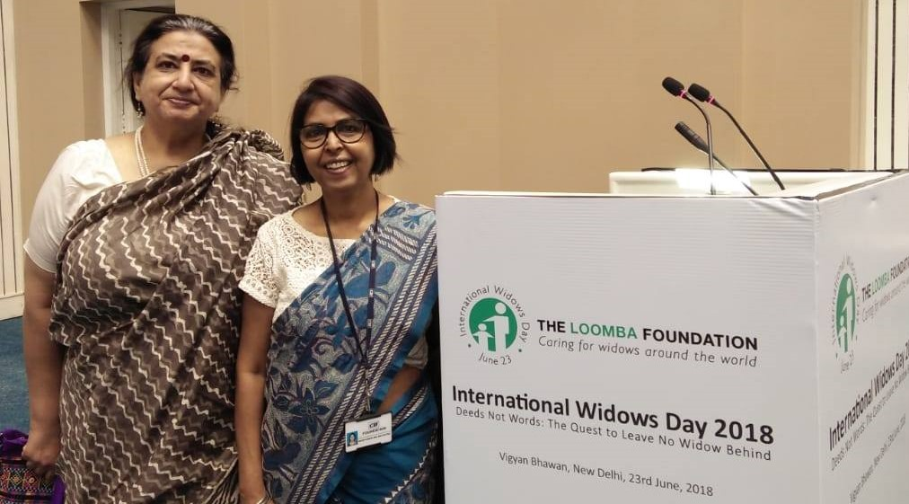
The iinternational widows day was observed on 23rd June at Vigyan Bhawan. Loomba foundation UK has been partnering with various organizations in India and other developing nations to work for betterment of widows and their children. They raise funds through various charity events and then further disperse them. In India the frontline partner of the Loomba Foundation is the Rotary Club. SAFP was invited to participate in their annual event for their interest in widow rights and dignity. The foundation had funded an international study " The status of widowed women globally: their needs and challenges." As part of its recommendations, presently Loomba foundation is partnering with government for skill development of widows and education of their children. As SAFP is also involved with the work for women in distress, it was of interest for the team to understand the private sectors involvement in their welfare. It is evident that each group that has suffered abuse needs immediate help to get stronger to deal with the violation. Once this is through then the person has to get back to their feet and get a job or be gainfully occupied. In case jobs are not feasible to get then the best bet for women is to set up enterprises they own.

Work with women and enterprises in India

During the year SAFP made several visits to Ministry of Women and Child Development (MWCD) to advocate for the need to set up the Women Enterprise Council India (WECI). The need for WECI has been felt by the very senior as well as young women entrepreneurs in India. This articulation has come from women who have begun their own start-up companies to those who have earned their profit and also those who do not. At SAFP consultations women entrepreneurs shared the need to gain strength to overcome gender discrimination in transactions which get biased due to economic controls of resources in a to a traditional social system. Pressure of triple gender roles needs to be addressed with provision of finance, market linkages as well spaces to work, manufacture, package and sell at their neighborhood as well as to distant markets. The WECI head office federated through a regional network will be a solution that needs to be discussed to agree to a way forward in the path of creating wellbeing for all in the country. SAFP proposed a base line research to the MWCD. The proposal was not supported but within a three-month period of submission of SAFP the WECI was set up. SAFP involved itself in organising the women entrepreneurs to know how well the new found WECI will work. It Contacted the existing Women Enterprise networks like FEWI. It was also involved in developing the resource base, invitation list and agenda for a two-day annual Vasundhara award programme of Sreemanta Shankar Mission of Guwahati held at PHD house Delhi in April 2018.The awards were conferred on women entrepreneurs from eight North Eastern states. Women entrepreneurs showcased their goods which were at sale in the PhD house. Different sessions based on challenges, financial constraints, resources, transport and marketing which North East India women entrepreneurs face was held.

In our endeavour to create a working partnerships with other organizations, SAFP worked with Sreemanta Shankar Mission of Guwahati for free distribution of mosquito repellents in Trilokpuri as part of the Johnson and Johnson CSR initiative in the month of May 2018. Ms Rakhee Gupta organised this work for SAFP.

Work with families who have a brush of mental health issues

Club House

Clubhouse was successful in cutting across various age groups this year. This year its members have organised meetings on their own. Over the course of last year, the clubhouse has been consistent in its membership. No new member was added but old membership planned outdoor and indoor activities. These members have to further extend invitations to newer locations in NCR to increase the membership of their wellness activity. They need to reach to Physiatrist and neurologists who could refer families to clubhouse activity.

Faculty Development Programme GB Pant Hospital, December 2018.

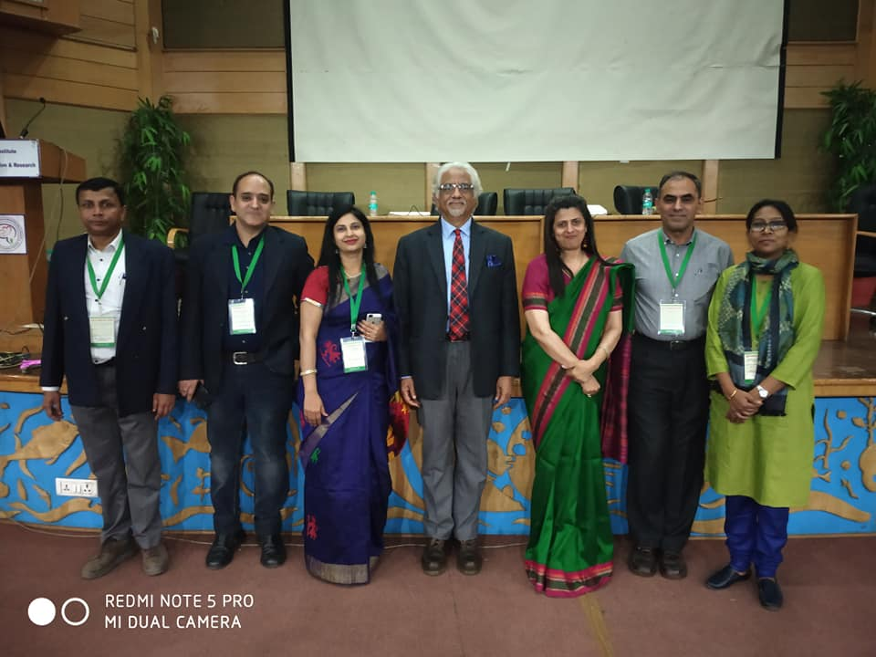
The faculty of the GB Pant Hospital was undergoing its going its annual faculty development programme when SAFP got an opportunity to participate in it. The faculty has invited HR strategy expert Prof Dr Debi Singh Saini to talk about globally acknowledged methods that empower both the employee and the employers. These strategic HR practices are based on principles of employee engagement. New development is engaging people in hospital management was a learning for SAFPs. Learning from this such information was shared with SAFP partners and constituents.

An unforeseen good also worked out as an outcome from this participation. Two of the clubhouse members are now awaiting referrals in the hospital and now that SAFP is networked with faculty SAFP would be able to guide them better to avail the service provided by GB Pant Hospital.

Work with Youth Leaving Care

SAFP has learnt about the world of Youth Leaving Care in the past two years. SAFP was invited to attend a conference on the issue Consultation for Aftercare Services in Delhi’ held at the India Habitat Center on the 14th of Dec 2017. WIth its background of work on inheritance rights the issue of right to inheriatance of the wards of the state came up. SAFP ideas were drafted in form of a paper on the subject that was published in a journal Published by Udayan Care called ICEB.

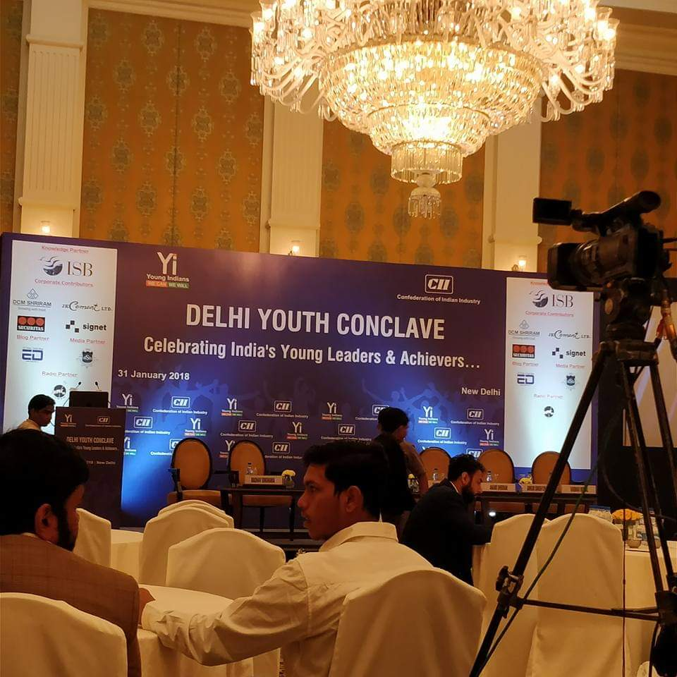
The Ministry of Women and Child development has recognised that Aftercare services as prescribed in the JJA have not been adequately instituted. Udayan Care had set up a Care Leavers Association and Network (CLAN) in Delhi that it wanted to slowly spread to other states. Meanwhile in Maharashtra Mr Aditya Yatri had worked hard to reach voices of care leavers to the government. Several consultations and workshops have already taken place to formulate official Aftercare guidelines but the state of Maharashtra was the first to present its guidelines with the assistance of UNICEF. Mr Yatri reached most information to the care leavers to find that the process of getting benefits is slow and schemes have not quite reached beneficiaries. Care Leavers are retraumatised over and over again and require a host of services to continue building resilience and skills. Not being in family and community set ups these youth need to be trained to develop and manage their constituency such that each can develop relationships towards a sustainable life. Empowering care leavers is difficult as young people choose freedom over a settled life; The youth need to lead themselves as an independent entity that gets support when they seek it. The Care Leavers are aware that they should reach out to others to develop their own networks but they need guidance from Child Care Institutions to organise themselves and support such local Associations. A group of CCIs got together by Udayan Care formed the Support for Youth Leaving Care (SYLC). SAFP is part of this groups to assist the process of organsing the Care leavers into a nationwide association. Towards this end SAFP is reaching out to stakeholders that a national training event should be organised in Goa during the year 2019. Care Leavers need skill building as part of Aftercare services. They require networks to be nurtured to support themselves for daily needs while working and continuing to skill themselves for better social, political and economic mainstreaming. They need mentors who can link them to employers and a caring community. A process to strengthen what exists can be worked upon by a facilitator that does not represent either the Care leavers, Government, the CCI nor the current mentors and employers as each has their stake. Sathi All For Partnerships has offered its service as a facilitator to the CCI for a period of two years. It will work upon a process that already exists.

January 2018 The Confederations of Indian Industries and Young Indian had organized a Delhi Youth Conclave

SAFP representatives are keenly participating the youth conclaves to be updated on how youth are being addressed and what their aspirations are. In time to come when the YCLA will get formed SAFP will make the YCLA members participate in these youth alliances to get into the mainstream activities. Mr Imran Khan organizes youth participants for youth centred meetings on behalf of SAFP.
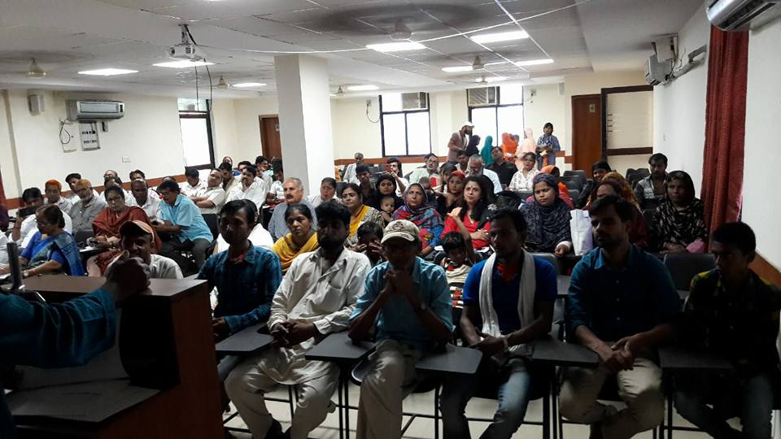
Work with the unorgansied sector workers

Working with workers network continued this year as well. The two mandatory annual programmes on May 1 and on the birth anniversary of Shaheed Bhagat Singh were held this year too. Different meetings were organised by members of National Alliance for Labor Rights during the first week of May.

Chapter 3 Research activities

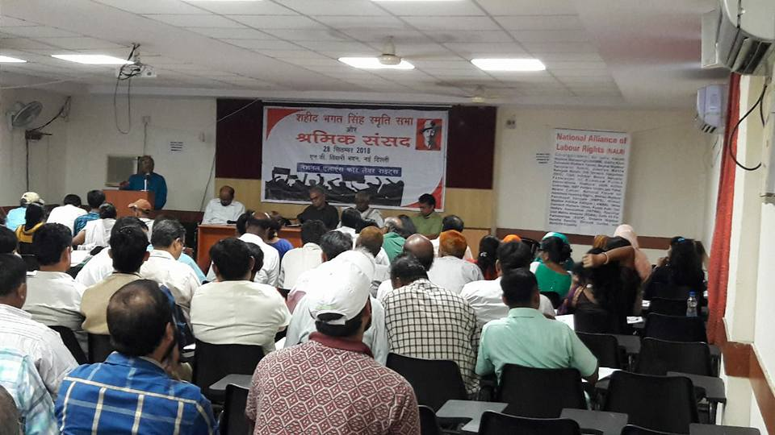
28 September 2018 Shramik Sansad or Workers Parliament was organised to reflect upon the context of workers' rights issues. This annual event is organised on the occasion of Birth anniversary of the great freedom fighter Bhagat Singh who used a non-violent bomb in the parliament to oppose the passage of Trade Dispute Bill - an anti-worker bill. This day was his 111 th birthday. Shramik Sansad or workers parliament commenced after a process of research into the current programmes of the labor ministry Government of India. Documents were studied and interviews conducted with stakeholders to study the situation such that workers could be explained how changes in the legal and administrative system may affect them.

The meeting began with Mr J John who works with tea garden workers of North East, explaining labour codes especially on the Code on social security. He asked the unorganised workers present what they understand as social security. Health and wellness, accident insurance they said. To this J John explained that it is a security given when a worker needs support for livelihood at the time the worker is no longer able to work due to infirmity or old age. It is a recognition of positive contribution of workers to the socio-economic system. The state and system thus become duty bound to provide social security to workers.J John quoted agrarian justice written by Tomas Pain who cites right of farmers as food producers. They work on land that may not own. The physical labor takes away capabilities making the farmer not able to work and earn after years of work. In such a state social security should be given. The labour codes in India today will erode what was handed to workers since generations. There are many layers of systems that protect the workers but as the case may be only those who have aadhar card may get benefit. Migrant and unorganised sector need facilitation to have address to get Aadhar registration. The code needs to clarify what security can unorganised sector avail. Representatives from different workers organisations also shared their understanding of the current situation to list solutions. NALR collated recommendations for submission to the government.

24 November 2018 Seminar on perspective of the workers on the declining Women Participation in Force in India
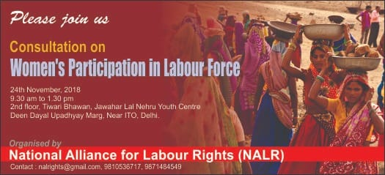
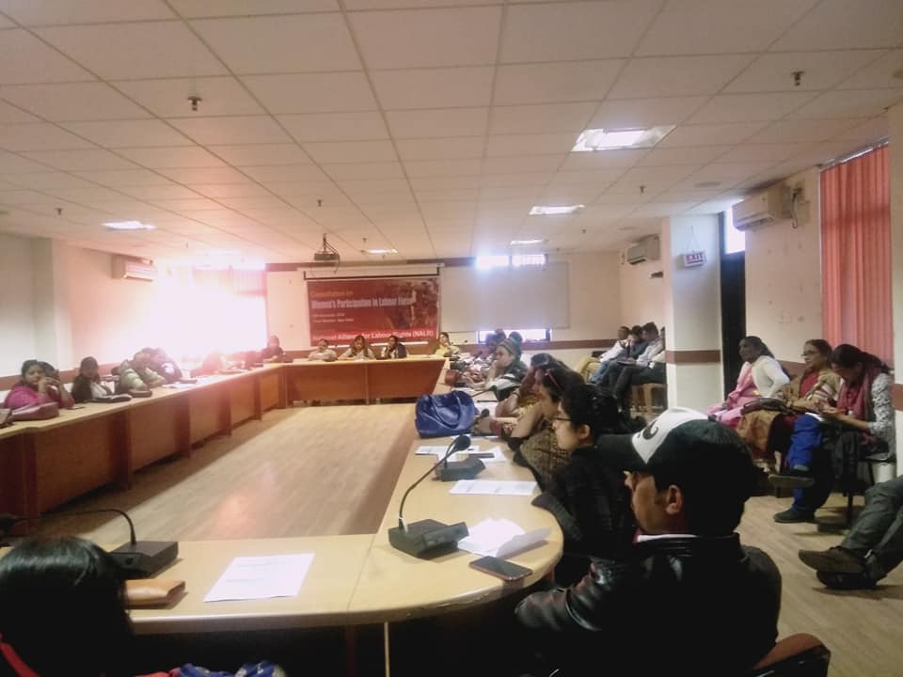

SAFP as part of the National Alliance For Labor Rights (NALR) led an event where representatives from range of civil society came to discuss the serious concern on the declining Female Labor Force Participation (FLFP) in India on November 24th 2018 at ND Tiwari Bhawan near ITO in Delhi from 9.30 am to 2 pm. The background note for this event was researched by SAFP to offer the perspective to participants and the participants provided rich input that formed recommendations which NARL sent to the ministry of labor. This event also was an attempt to offer solutions at policy and practical levels through a panel response to issues raised by workers on FLFP. A short concept note was developed after a research process to enlist support of both academic as well as activists. Women workers from different sectors placed concerns to also offer solutions before resource people to enlighten the audience on issues and solutions. The policy take away from the event needs to be further refined after sequel meetings.

Updating SAFP on research conducted by other institutions Pushing the frontiers of evaluation effectiveness and excellence: 3ie's first decade conference was held on 19-20 April 2018 New Delhi. This was an insightful conference with panelists from World Bank,UN Women and Bill and Melinda Gates Foundation. The impact evaluations had been done on varied issues of health, water and sanitation, gender-based violence across the globe. This gave first hand sharing experience to the team of the challenges faced by the development sector and ways to combat them.

A seminar was held in October 2018 by Centre on Gender Equity and Health, University of San Diego and Lakshmi Mital Institute of South Asia, Harvard University on Impact of violence on Adolescent health, child marriage and violence and effect of reporting of crime on security of young girls in Delhi. These topics had been researched and their findings were shared. SAFP was invited to participate in the seminar. This helped the team to voice its opinion on GBV and need for creating safe spaces for its youth.

Chapter 4 Awareness events, Trainings and Policy Impact

SAFP built the capacity of its members to be trainers and works with child and human rights groups to provide cross learning and links different spectrums together. SAFP works with children, youth, women and men on gender equality issues and plays an active role in articulation for migrant & unorganised sector in urban and rural areas, tribal and Muslim women, and mental health issues survivors. SAFP has developed tools for national ministries and planning authorities to mainstream gender and mental health in their agenda.

The concept of Women Resource Zone (WRZ) Shared with Dwarka Collective on 3rd Feb 2019.

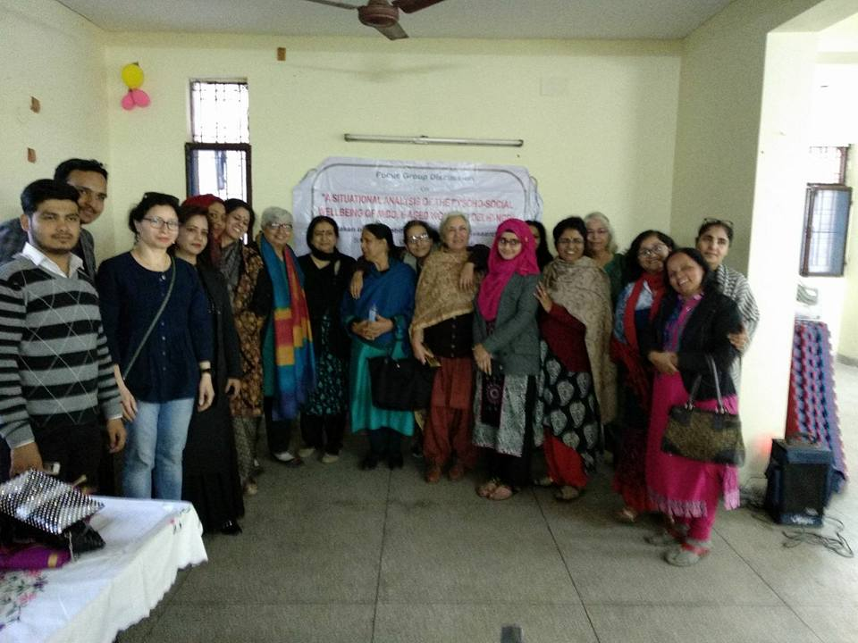
Safp team was invited by civil society organization, Dwarka collective at Dwarka on to talk on need for economic stability and creation of resources for women in the community. Idea of creating the women resource zone was reiterated. The idea was received very enthusiastically and clarifications was asked to understand ho women will ask the government and Corporates for spaces to manage and set up care services and enterprize. The middle-class women had got along with them working class women thinking that the workers will put forth their aspirations, while the workers listened through quite puzzled that their employers may want them laid off from their current work. Most workers were either house maids or supplier of food or groceries at the homes of the middle - class women.

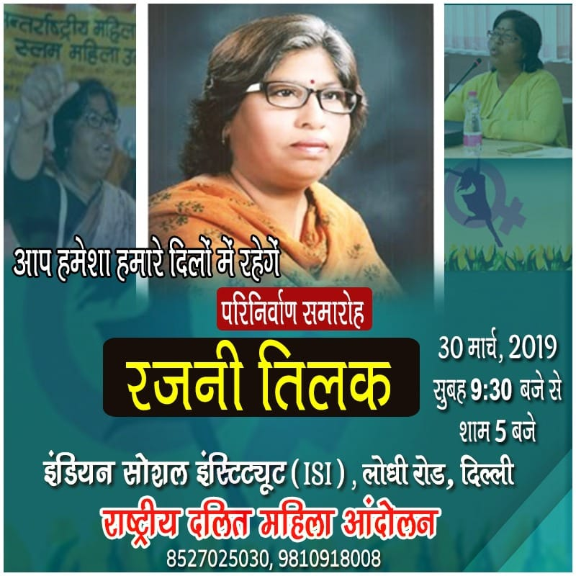
Meeting on March 30th 2019 to work on strengtheining the legacy of Rajni Tilak Rajni Tilak, passed away last year on 30th March 2018, leaving behind a rich legacy of her vibrant Dalit Feminist, Buddhist work that had leaning towards the workers and the those who toil. Her immortality or punarnirvana day was organised across India by people who have known her work in different capacities. For example, the Maharashtra groups organised a three days literature festival around March 8 in Rajni Tilaks Memory in Nagpur. Her NACDOR family got together in Delhi and asked Ms. Sumedha Boudh, as a representative of the movement Rajni created in the formation of The National Dalit Women’s Movement or the Rashtriya Dalit Mahila Andolan (RDMA) to organise a meeting to talk about the various facets of Rajni – her work, her vision and the causes that she tirelessly dedicated her life to so that a way forward to strengthen her work and her legacy can be planned.

The meeting in Delhi was organised to hear from different people on what they though Rajni Tilaks legacy was. The invitation was circulated from RDMA with support from NACDOR, NALR, SAFP and ISI. The programme was conceived by NALR (National Alliance for Labor Rights) as Rajni was one of its founder members. SAFP has worked with Rajni Tilak to plan addressing Dalit Women Resource Gap and was approached by NALR to support RDMA as it works on increasing resources for Women collectives as part of its work on training women to focus on developing their independent resource base to contribute to collective responsibilities. SAFP will support RDMA for next two years to strengthen its leadership and resource base. Ms Jyostna Siddharth daughter of Rajni Tilak was invited to be a part of the process to contribute to the collective legacy of her mother. Indian Social Institute worked with Rajni Tilak to develop content and perspective for its Dalit periodical. NACDOR is committed to carry forward itself for a life time to Rajni Tilak’s legacy as it was also cofounded by Rajni Tilak and her mentoring its leaders. The meeting concluded on the need to complete the unpublished writing of Rajni Tilak, strengthen different Dalit writers and cultural forums Rajni had initiated and to train the existing RDMA members to strengthen its membership and leadership to become like Rajni Tilak.

Celebrating Women’s Day

International Women’s Day Special Seminar organised by International Initiative for Impact Evaluation (3ie), at India International Centre, New Delhi on Transforming Women’s Lives: Lessons from the Impact Assessment on 8th March 2018. Monitoring and evaluation analyst at UN Women India, had discussed about the evaluation of the Shaurya Dal programme that was underway in Madhya Pradesh.
The impact assessment of the programme in terms of the efficiency, effectiveness, relevance and sustainability was analysed. The Shaurya Dal programme is unique in its approach to tackle violence against women and girls by community-based intervention and participatory mechanism in the state. The Shaurya Dals include appointed members per ward and per Gram Panchayat who are entrusted with the responsibility of mobilizing the women and men of the locality to report and fight against violence against the former. Means to combat the social peril includes negotiation, mediation and mutual agreements wherein the active members of the Shaurya Dals would facilitate the attitudinal shift amongst the community by creating enabling environment for the women to place their opinions and discuss personal experiences with them. Since SAFP has worked on the wellbeing of the middle-aged women, it was interesting to learn that both the beneficiaries and the facilitators in the Shaurya Dal community project in Madhya Pradesh are also middle-aged women. The other talk was delivered by representative of ICRW who evaluated the GEMS and PANKH programmes underway in Jharkhand and Rajasthan respectively as a systematic intervention of the state and the participatory NGOs to deal with adolescent violence in the state. The programme advocates intermingling of adolescent population of both sexes amongst themselves and thereby envisages inculcation of knowledge and awareness among the youth concerning their needs, health, problems in their life. This programme had facilitated an enabling environment for the young girls to discuss menstrual health and hygiene. These state initiatives were not only limited to adolescents but it was involved their mothers and elders in the community.

The uniqueness of this programme lies in the fact that it was an ice-breaker bringing a change in the mindset thereby enabling an ecosystem where equal participation was forged across the generations to discuss subjects which were tabooed. The seminar thus provided a thorough understanding to the Safp members towards the need of community based interventions at the grass root level to fight the incidences of violence against women and girls in India ensuring inclusive approach.

SAFP Awareness for the Aces in India

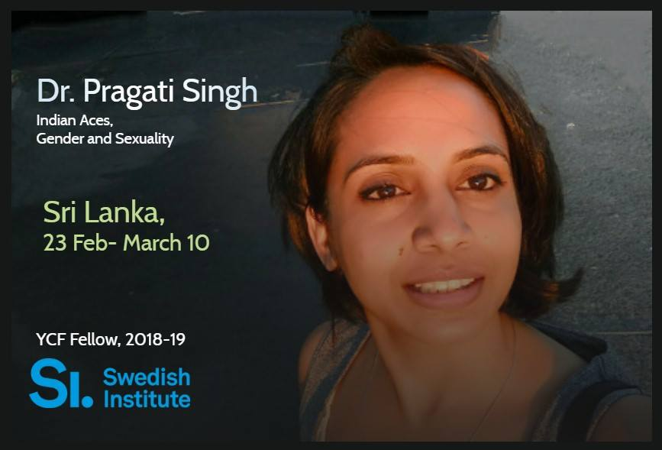
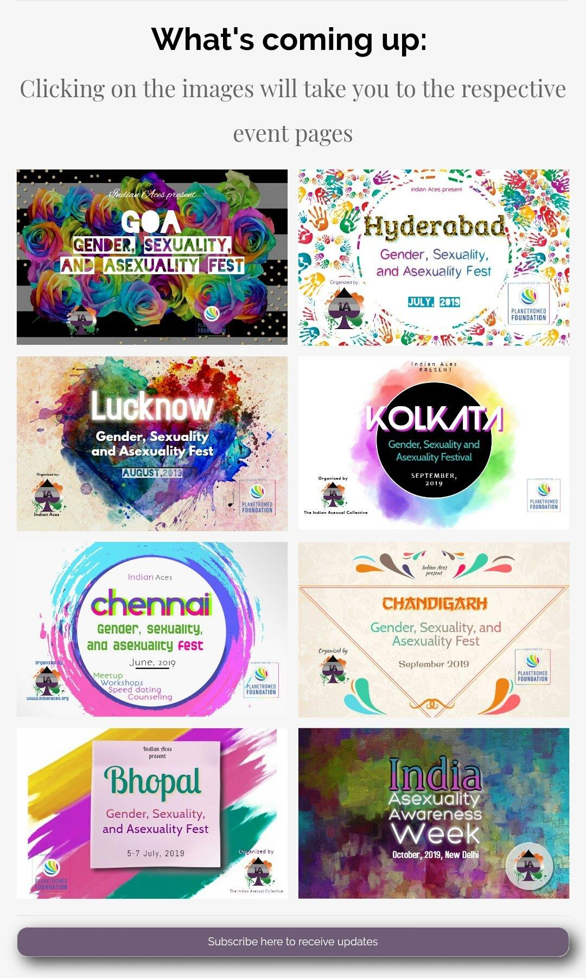
SAFP ventured into understanding the world of the Asexual this year. Towards this Dr Pragati Singh of Indian Aces was supported to set up a project called Aces Going Places (AGP). In preparation for the role Pragati undertook training and planning of course content this year to prepare herself for the project roll out next year. She travelled to New Zealand and Sri Lanka to meet with communities and professionals to formulate her workshops. By August 2018 she made the Aces Going Places plan public on social media to increase outreach as by then support from PlanetRomeo Foundation was secured for workshops in different cities of India i.e. in Chennai, Mumbai, Bangalore, Hyderabad, Panjim/Goa, Mumbai, Pune, Bhopal, Kolkata, Chandigarh, and Lucknow. SAFP agreed to partnering with Indian Aces to understand the issues around sexuality and exclusion and its relationship to resources for those who want to live within the dignity of choices they make.
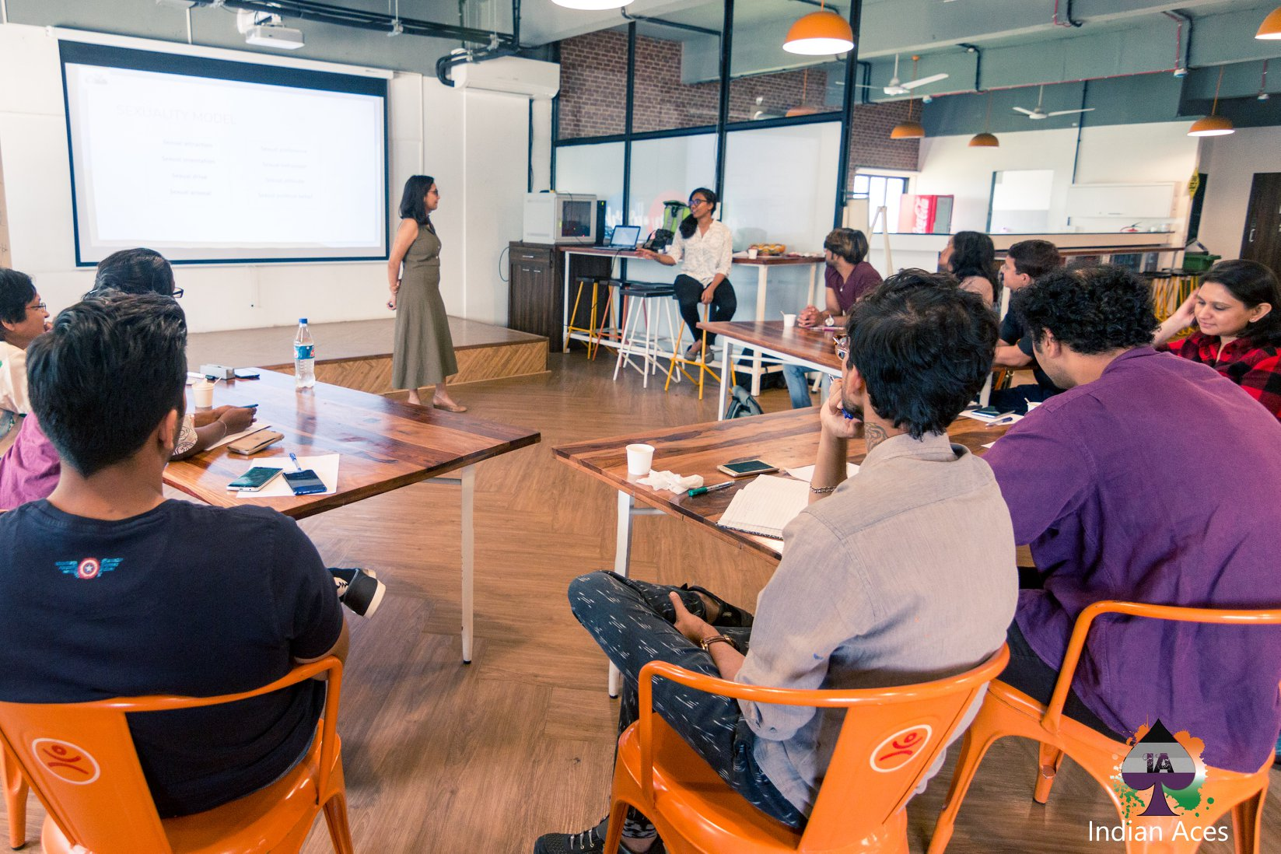
Indian Aces conducts advocacy, awareness campaigns and workshops and events in the fields of gender and asexuality on the independent initiative of Dr Pragati Singh for over 5 years now. She has trained professionals and the lay person to facilitate a conceptual understanding of gender and sexuality through a revolutionary model on the subject. The educational workshops that have been planned through Aces Going Places project are designed to be intellectually stimulating and challenging as it provides services through meetups and counselling sessions. Led by Dr. Pragati Singh of Indian Aces Delhi, India, a majority of their events were so far hosted in the capital. With support from PlanetRomeo Foundation it will be possible to make ignorance on asexuality into creating space in India that can understand it such that people can make choices and participate in the talks about moving from 'tolerating' diversity to 'accepting, embracing and celebrating' it.

28 October 2018 Young leadership Summit at Leela Ambience Hotel Gurgaoan, organised by National Human Resource Development Network.
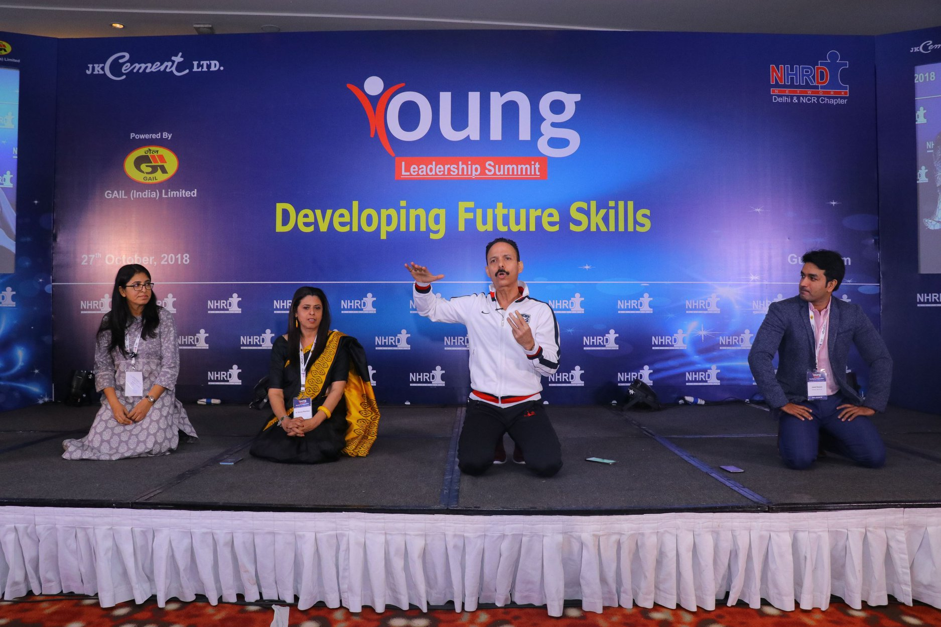
The National HRD network programme on Young Leadership Development informed the participants what organizations require to hold on to talent that they train. It is a known fact that youth is restless to move on to new pathways if their talent and potential is not utilized optimally. They have more hunger for information and work with a different perspective. New ways of working together are required by people who manage young staff members. It is also the case that organizations are hiring younger managers to work virtually across geographies. New ways of working and managing will require flexibility and breaking down tasks into small doable bites. Core skill needed would be change readiness, critical thinking and innovation. SAFP participated in this learning event to understand newer ways of working such that it could translate these learnings into programmatic value.

Planning Ahead

The year ahead will carry forward activities on safeguarding vulnerable communities that SAFP was able to reach out. Research publications are planned to capture work done through the year.

Chapter 5 SAFP Collaborators and people

SAFP Board of Trustees 2018-2019

President : Dr Vinay Bhardwaj
Program Director : Ms Sharmila Mahajhan
Founder : Dr Shivani Bhardwaj
Trustee : Ms Manu Tyagi Baijwan

SAFP Staff

Executive Director: Ms. Deepika Nair
Ms. Pranjali Malhotra Programmes SAFP India
Ms. Sunita Gupta Kotnala Programmes SAFP Australia

SAFP Associates

Dr. Pragati Singh -Aces Going Places Project
Mr Imran Khan – SAFP Youth and Child Rights Collective
Mr Aditya Yatri – Youth Leaving Care Association Project

Collaboration with Partners : Nirmana, Indian Aces, SACH, Bhartiye Jan Parshad Manch and the Paramhansa Yogananda Trust.

******

Udayan Care, Prayas, El Sheddai, Rainbow homes, SOS Allumina, Centre for Excellence in Alternative Care of Children Sallam Balak

