# Annual Report SAFP 2021 April to March -2022

**Chapter 1 Introduction**

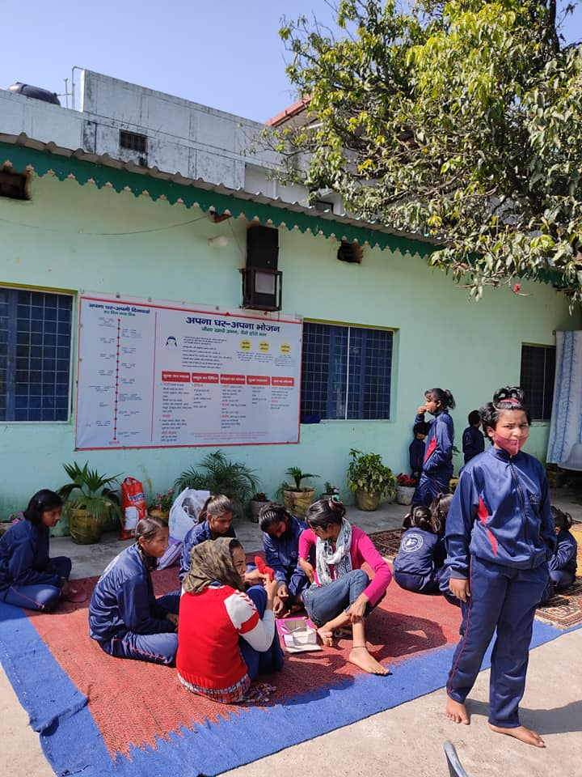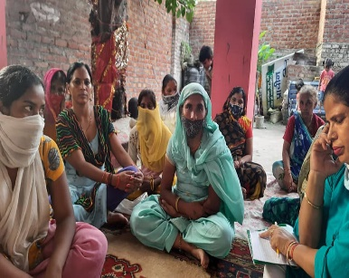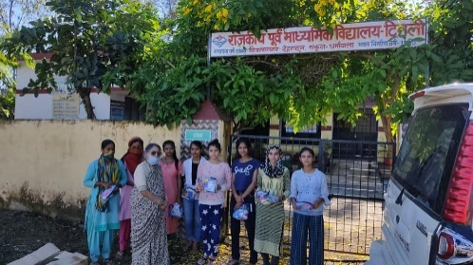The activities in this year can be seen within the categories of covid work, leadership support and consultancies. The Covid work involved awareness raising against the misconceptions around the vaccine and distributing food, sanitary napkins and medical supplies along with counselling. With support of Rotary International covid kits were distributed among the poor and needy while drive for awareness was conducted across three states. Four consultancies during the year got the research portfolio of SAFP furthered. The Kritagyata team of SAFP engaged over a dozen counsellors to provide mental health support through out the pandemic period. The covid work and consultancies helped raise awareness on our long-term mission of reducing gender resource gap through allocations to women and develop leadership of the vulnerable. We were able relate with partners and collaborators to develop human resource that would take the concept of woman resource zone forward. The social capital earned during the year was higher than the financial as what we could generate as grants was directed at getting the beneficiary aid directly from the person who wished to donate. This way SAFP supported the fee for 20 students through Girls aspire project and through project Kritagya as well as supported uniforms for 40 orphan girls at Apna Ghar. The direct donors to Apna Ghar were Mr Vonid Kumar and Ms Ashita Mittal. Ms Swati Sharma, Ms Margret Rai and Ms Nandini donated to the orphanage in kind. The take away for SAFP was to enroll Apna Ghar as a member of SAFP strategy to make Orphan Women leaders for the WRZ plan in Dehradun. During the course of the year, SAFP contacted different entities and women leaders to understand the ways to address the gender resource gap. Apna Ghar Inc in Chicago as another home of destitute women that SAFP got in touch with to provide voluntary support in form of inputting towards their finance manual for destitute women who came to the shelter.

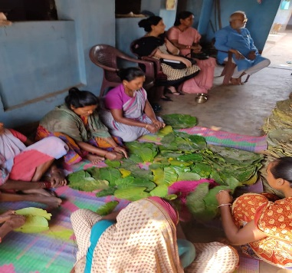Back home women and care leavers hit by Covid were organized to seek counselling, attend wellness programmes organized by SAFP members. A woman workers forum was set up in Delhi and they understood options for them self and enrolled for trainings to set up their enterprise. SAFP worked with WICCI Uttrakhand to collectively develop an understanding on how different women led enterprise can add an element of mutual benefit for each other.

Towards the year end Badlao Foundation contacted SAFP to discuss its gender strategy. SAFP team visited Badloa foundation field areas to understand how the two organizations could merge their agendas together. Badlao Foundation has already registered Mutual Benefit Trust (MBT) of women in Jamtara and Godda districts of Jharkhand. They also have women organized in livelihood teams as well as infrastructure that MBT could use to reduce gender resource gap for them selves as well as their own communities. SAFP and Badlao Foundation have developed plans to further the empowerment of the MBT.

**Chapter 2: Training vulnerable to lead their communities**

**Leadership of vulnerable women** SAFP is working with vulnerable communities since its inception. The focus has been to develop women leadership in all communities we work with.

**Mentoring Widows**

From April 2020 to March 2021 SAFP was in constant touch with widow’s who had lost the main bread winner to Covid. Ms Manu Tyagi Baijalwan and Ms Rakhi Gupta took a lead in this work. Ms Rakhi who was herself widowed this year resurrected from her grief to not only help herself and take charge of her situation but also assist other women for whom the situation was similar. These two members of SAFP worked diligently at different levels to reach out to over 150 women across India. A case that was dealt with in September 2021 can explain the kind of work done by SAFP team. Mrs X ( name not disclosed for privacy issues) was married from north India middle class family to a Telegu speaking business owner who died dur to Covid. Mrs X did not speak Telegu and did not understand paper work of her in laws who transferred the business and house ownership documents of the dead husband to their name. It was only when a lady officer of the district house registration called to ask her if she had no objection to the transfer of house and property did she realize that her husband’s family is disowning her. Fearing her life in such a situation she fled the husband’s home to live with her parents. Since her family has little to go by she wants to reclaim what belongs to her and her daughter. Ms Rakhi Gupta helped this woman with contact with the police and counselled her to be strong and get back to the marital home as directed by the police. Dr Bhardwaj continued to support her with information on how to be bold to take on her rightful share from her in laws.

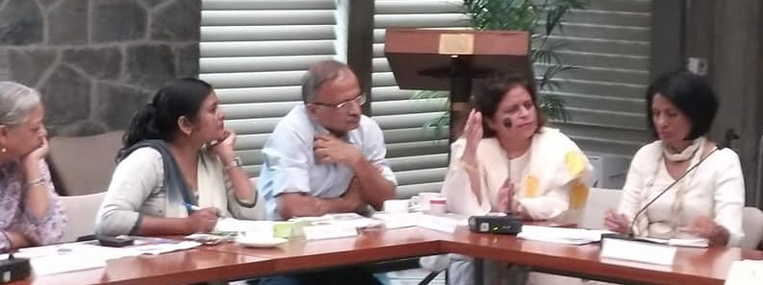

Ms Rakhi Gupta has coined herself as a people’s representative or a Jan Parshad. In this capacity she represents the vulnerable at different forums. She attended the international Widows days meeting organized by Guild of services this year too. This meeting was organized at the UNDP hall where other imminent actors were present. On the occasion Ms Rakhi launched her publication that she had written on Vrindavan widows before the pandemic. She was able to let the audience know that a multispecialty home was created for the widows with facility to house a 1000 widows in distress in Vrindavan but the facility was withdrawn during covid and widows, most were aged looking for accommodation and a place to get food when the facility was transformed into a covid ward. Ms Rakhi appealed to the forum to support the vulnerable during such difficult circumstances.

**Leadership work with Dalit women**

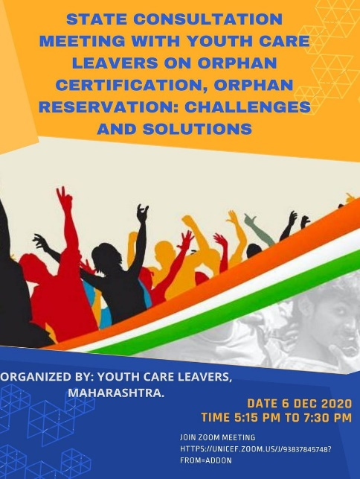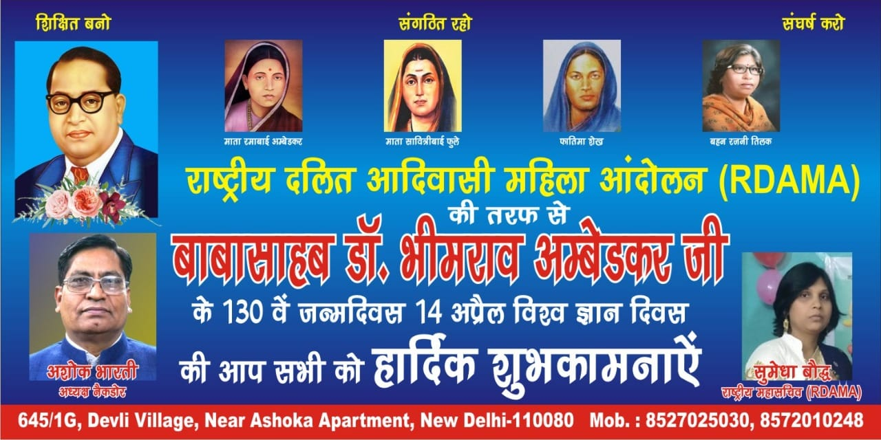SAFP training work with RDAMA was to be for a short period. Yet it’s relationship with RDAMA members continues. The covid times have been particularly rough of Dalit and Adivasi women who faced lack of income as men of their families migrated from town back to rural areas flooding homes where the woman had to cook meals and serve to many more mouths than last year. Thankfully most of these women have begun to set up small work such as vegetable farming and sowing work. Ms Pushpa Vevek President of the RDAMA was unwell during this period but she kept sharing inspirational videos and information to activate the members. The videos of Kamala Bhasin were shared frequently even so after her illness and her death in September 2021. She suggested that RDAMA embers apply to set up Eshram portals that government was initiating. Ms Sumedha Baudh the General Secretary took another way. She got to set up her own enterprise this year near her home to put information provided by Ms Pushpa ji in practice. Her way is to set an example that she can be a bread winner of her family. This did not mean she did not carry on her activities. She went back to work for the NGO that could support her and assist her to organize awareness campaigns as before. Ms Kanta Baud based in Hyderabad continued her activities online and offline like many other RDAMA women leaders.

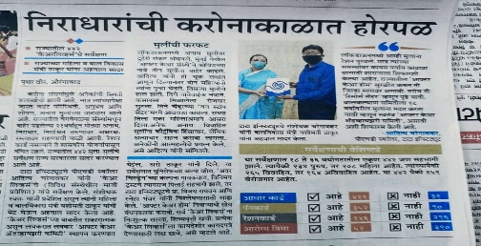**Aftercare Leadership** During the second wave SAFPAftercare leader Mr Aditya Charegaonkar ( read more about his journey at [A Tale of Social Impact - Intrapreneurship... (alumnest.org)](https://alumnest.org/f/a-tale-of-social-impact---intrapreneurship-8771?source=view&utm_source=Campusfeed&utm_campaign=Campusfeed-Sharing&utm_medium=Facebook&fbclid=IwAR0P4WQLKACA-mr03Icj3XcJ8TrYQHol06qoELRidh8jXxi3MNmTYxeHbZc) )worked relentlessly to seek assistance from different levels of leadership to serve the constituency of those who had lived in a Child Care Institution. His work ranged from meeting leaders at the local and state level. In the news item at the picture Aditya is presenting the concerns of aftercare youth the secretary of Women and Child in Maharashtra. He was part of investigation of what is happening to aftercare youth while they suffered due to Covid. This moved him to organize ration support to some members of the Youth Care Leavers Association (YCLA). He found that many young people do not even have their basic Identification Documents (ID). He advocated for the basic as well as many other needs, wants and rights of the wards of the state with the right authorities. Advocacy without linking to ongoing solutions falls flat. While SAFP could not provide any financial assistance to Care leavers this year unlike last year, it kept link with Aditya by maintaining communications to try for developing linkage for his work with other SAFP work like Kritagyata. Aditya associated with different care leavers in Maharashtra wherein he assisted a children home and youth hostel to clear up the debris to initiate a playground for the youth. He also began counselling session in youth hostels and organized group activities for youth to feel included in social work around their hostel. Towards this end Aditya participated in different activities of Swatch Bharat Abhiyaan.Along with other Care leavers across the nations Aditya participated in care leavers café discussion online as well as offline. SAFP wrote three articles on care leavers to assist the YCLA articulation. The Azim Prem Ji Foundation approached Aditya this year to support the cause of care leavers. This is work in progress and it is hoped that the care leavers agenda will be developed with support of the foundation in future.

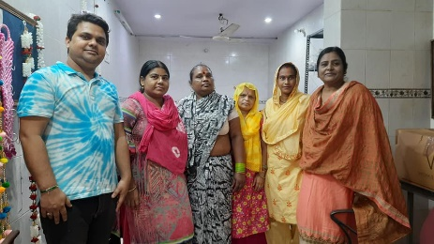**Work with Youth** Mr. Imran Khan worked on different charity mission food distribution during the Covid highs. In particular he was visiting the farm workers in Yamuna Khadder to understand their needs during the period there was no work and they got no wages to be able to buy food**.** Imran was a great support to women that were being organized by Rakhi Gupta in Trilokpuri. He was also helping elderly people by reaching services like medical assistance and for paying bills, repair of equipment to those who were of age.

Imran worked with Youth ki Aawaaz to contribute to this social media platform, stories that had social relevance and message for the young on different areas they could feel inspiration. These areas ranged from sexuality to social action. Along with SAFP team Imran participated in research with Ms Sudeshna and Wasima Aktari in research on access of government schemes to the marginalized. Imran conducted interviews to develop case studies of ten youth for this national research. This research as supported by Action Aid.

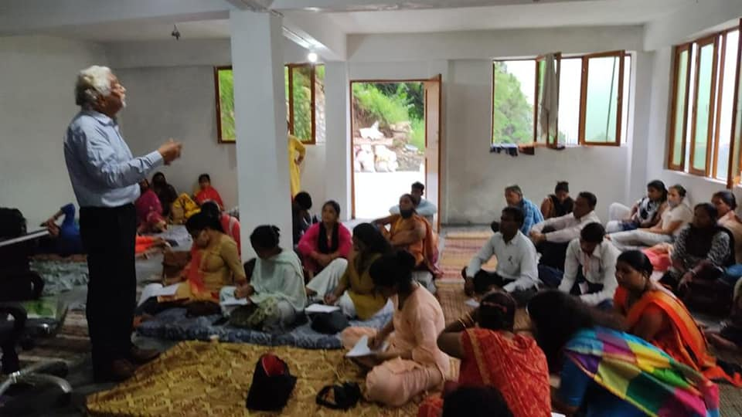**Work with the unorgansied sector workers** A continuous dialogue was carried out through the year with workers with help of zoom meetings with different workers. These were forest workers, construction workers, ragpickers as well as domestic workers. There was much dis tress regarding the codification of the laws into four different codes. SAFP along with experts dispelled confusion to update workers within its network to develop awareness about what lies ahead. On May 1 SAFP assisted a national level organisation to hold a zoom seminar on labor welfare measures planned by the government. Towards this end SAFP linked the NGO with contacts within the Ministry of labor so that confidence building could take place directly from the agency that was trying to reorganise the benefits into the Shram or labor portal offered by the government later in the year.

On August 8th 2021 SAFP provided training input to Construction and Domestic workers of Nirmana. The sessions were pertaining to developing a vision for the future of the organisation to initiate the second line leadership consisting of equal number of male and female members. Dr. Debi Saini took a three-hour session on team building as an important aspect of leadership of the workers.

### 

**Chapter 3 SAFP Consulting and Learning**

**Work with women and enterprises in India**

**WICCI Uttra khand**

SAFP was active throughout the year to support the formation of WICCI Uttrakhand. This work as led by Project Purkul Director Ms Amrit Barret and Ms Mamta. This activity comprised of outreach to both educated and non-educated women who have been running their own businesses. Proposals were discussed to highlight their work and raise demand collectively to develop women resource zones in each neighborhood. Ms Neha Jitender developed the proposal for Ikea Foundation which could not be submitted as the requiements required proven model that SAFP did not have.

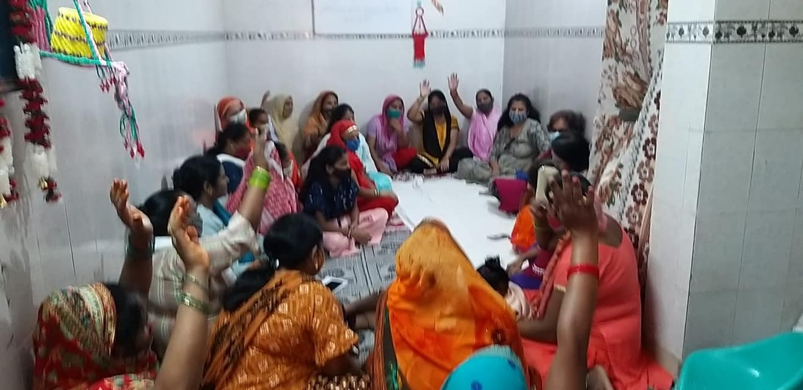**Individual enterprise:** Team Awara Guftar of which SAFP is a part, has two women entrepreneurs who are developing their enterprise as women led one. Ms Nahid Aqueel is one of the entrepreneur who reinvented her model of work to suit covid requirements of sanitization during second wave of Corona. Another member Ms Poorobi Menon is a language instructor. She gave this career a halt to build a complex next to river Brahmaputra in Assam during the year. The work of women and land right is a long standing one for SAFP. In advocating for inheritance, it is also important that women who do belong to families that can show the way where women build and make use of the land they inherit from the families. Ms Neha Jatinder set up Nams creations to repurpose old fabric into new designs. Her designs were used as wedding wear and they reached the USA this year. The wedding photographs were circulated and her enterprise got repeat orders and new clients from this initiative. Ms Rakhi Gupta too began and enterprise of collecting old household articles for sale in the bottom of the pyramid communities. Her first givers were from SAFP community. Ms Prem, Ms Yojna, Ms Sonal and Ms Arundhati were supported by Dr Bhardwaj in the move on managing the properties in their name to earn revenue for themselves. On October 10, 2021 Ms Rakhi inaugurated the individual women entreprenueurs group at the SAFP field office in 5/233 Trilokpuri. This group is called the Delhi Mahila Kamgar and Sahayta Samooh. Ms Akta provided input on how the women could approach corporate support for their enterprise. She got a group to donate free sanitary napkins and chunnis at the occasion. A what’s app group called Trilokpuri sakhis was created to support these women with proposals. After many attempts Rakhi was able to collaborate with ONGC to get three sowing machines for a tailoring training event that as organized for week on 22 March 2022.

**Dalit Women entrepreneurs:** SAFP was invited as a panel speaker for a program called Women@75 that was held virtually on 13th August 2021. The theme of the Women@75 was "Volunteering for Leadership; Future in Entrepreneurship." More than 100 women activists, entrepreneurs, writers, journalists, home-makers and volunteers from across the country participated at this event. During this year-long observance, the organizers of the programme, NACDOR had worked with Dalit women to set up their enterprises. Some Dalit women had set up retail shop business that was based from their homes. The experience to begin work during the corona times as struggle ridden. It was in this backdrop that imminent people including journalist, and National Commission Of Women representative Madam Rekha Sharma were invited to speak to the women. Not with-standing the difficulties, the women who attended the programme were inspired and motivated by the program. Some of these women were happy to report in December that their enterprise is still alive and they are about managing to break even with their work giving them a return.

**SAFP Consultancies**

NGO called Mittika that trained SAFP representative on applied theatre techniques in February along with other professional trainers. This was a unique experience to brush up training skills that were to be applied in a sequel assignment with Mittika. This assignment was the work of IFMR lead which had invested itself on analysis of a study conducted on the Gender based Violence of response of Bihar police. The research found that the police did not support the victim as they are themselves from a culture rooted in patriarchy and feudalism. A training module was designed for attention of Mittika trainers such that a training framework on GBV could be discussed. SAFP was requested to suggest Bihar based trainers for an assignment to conduct training of police offers in five different locations. Two trainers suggested by SAFP were take on for the assignment. This assignment however could not commence to conducting the actual training due to the Pandemic. The manual produced from this experience is the property of IFMR and Mittika.

Dr. Sudeshna led two researches during the year on behalf of SAFP. One research was on safeguarding framework for children in India that was done as consultants of TAAL for an entity called Educo and another was on understanding who got government schemes with dignity. These were national level researches that required on field interviews and desk research. Sudeshna was assisted by a team from SAFP while she directed the team consisting of Wasima Akhtari and Imran Khan. She also collated learnings from SAFP work till date. The research outcome from this piece of work is sent for publication in a reputed journal. Dr Shivani Bhardwaj provided support in terms of specialist inputs.

Dr. Bhardwaj led and Evaluation of a livelihood programme in Feb 2022. This evaluation involved SAFP team that worked on the different aspects of the evaluation. Ms Vandana Mahajhan was the gender advisor, Mr Rahul Bannerjee computed the data while Dr. Sudeshna Roy and Ms Deepika Nair collated the data. This task required extensive travel in the field areas of Jan Sahas whose livelihood programe as undergoing an end term evaluation.

**Chapter 4 Awareness, Research and Advocacy**

**Covid giving’s and awareness on covid vaccines**

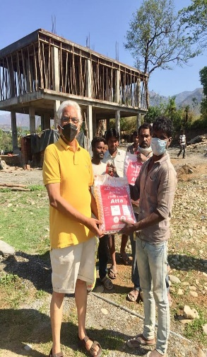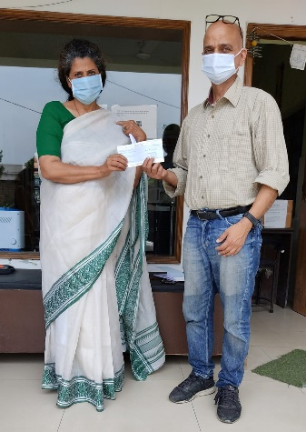SAFP members and friends across the world were moved by the migrant workers they saw on the news. This was followed by the massive shortage of space in the hospitals and lack of oxygen supply situation. Lock down and lack of movement inhibited work but then partnerships were set in place with doctors who had permit to travel to reach patients in need. Ms Sunita Gupta Kotnala donated a sum to assist people in distress and her donation was put to use by collaborating with Dr Nitin Pandey of Saheli Trust who was supplying fresh food to people at the Corona Ward of the Doon hospital. During lockdown Dr Pandey had secured travel permit to reach food and SAFP thus collaborated with Saheli Trust. Ms Sunita’s assistance as also utilized to feed workers who were building projects but were stuck at the work site due to lock down. Their contractor was away and could not send them money for ration. SAFP filled in the void by distribution of ration and kerosene oil for them to be able to cook food while help through the employer’s channel arrived. A portion of the money was donated to Ms Chitrarupa Palit for her medical expenses due to Covid complications. Purkul project was also distributing supplies in rural areas of Uttarakhand. Since SAFP was collaborating with this project locally SAPF too assisted in this task along with them.

Ms Seema Jay Kumar has been very busy through the year with a load of case work for counselling. Ms Vandana Mahajan supported a team of domestic workers during the pandemic to cope with Covid.

Mr Ashok Bharti was hired by SAFP to fund raise for Covid and other work of SAFP. Mr. Ashok Bharti raised a financial resource from his network to buy distribution kits for young girls from Rotary International in Australia. Each kit contained hand sanitizer, masks, soap and sanitary pads apart from basic medication to lower fever. These kits were distributed in three states of India. From April 30th to May 4 2021 a Vaccine Education and Awareness Campaign (VEAC) aimed at countering anti-vaccine propaganda, misinformation and helping people to overcome their fears and anxieties on pilot basis was conducted in three locations of Delhi. This program like all our work was a partnership between SAFP, Centre for Alternative Dalit Media in partnership with Mantra Social Services organized. This Vaccine Education and Awareness Campaign in various locations in Delhi for two days was planned to get women workers out during lock down as we had reports of violence within homes increased during lock down. The role of the organizations was planned strategically in this activity such that the VEAC Campaign helps SAFP to strengthen its long-term role of training Dalit women leadership. SAFP conducted a two-day training on safeguarding to train staff members of CADAM to conduct the activity as per a strategic plan. CADAM staff members took training towards implementation in a way they could reach their services through service providers to impact both men and women equally. Two Vaccination Education and Awareness Camps in two different locations – Sawada and Narela, for two days were conducted by CADAM whereas SAFP organized camp in Trilokpuri for one day. Each camp was setup and three specially designed and printed Banners were put up in each location. These banners had the names and logos of CADAM, Mantra, Surya and sponsor Zeerodha along with the campaign message. CADAM and SAFP deployed 8 volunteers every day in these three locations.

|  |  |
| --- | --- |
|  |  |

Volunteers at the VEAC Camps were those SAFP had trained to become leaders in the previous years. It was the background of work that came of use to give the women the courage to come out and work during the pandemic. CADAM’s women volunteers (ABHAs), trained by SAFP were deployed there interacted, motivated and guided people about the benefits of the Covid-19 vaccination. CADAM’s Women Volunteers handover/distributed about 2000 handbills. CADAM Volunteers ensure that everyone visiting the VEAC Camp in these locations, gets a printed handbill in his/her hand for educational purpose. As CADAM Volunteers were local, it made deeper impact and demand of vaccination has increased since.

**Research Work**

**Social Role Valorization**

The Key stone foundation has included SAFP as a member of its writing and research group. The group met regularly on line through the year to discuss issues around disability and the problems faced by the excluded during the lockdown. Many of the members of SRV team are parents of the children who are autistic. The pandemic has not been good for those who need to be in communication with nature more than human beings. Parents found a opening to discuss issues faced by their wards at the zoom meetings. Mainly the discussions assisted the participants in reorganizing their routines to develop alternative schedules to accommodate changed circumstances.

SRV members were active in a campaign that asked government not to dilute the Rights of persons with Disability Act 2016 with provision that curtailed their employment. This on the government web site was uploaded after a Manager of State tourism facility of Nellore beat up a disabled woman colleague and she lodged police complain. The disability NGOs petitioned the government to withdraw this amendment and it was withdrawn. While SAFP is not a disability organization and did not lead any discussions, it raised awareness of what the amendments might result in disability groups through word-of-mouth phone calls and home visit meetings. One such meeting was held with members of Arunima that is a facility of Autistic adults in Dehradun.

**Action Research for WRZ**

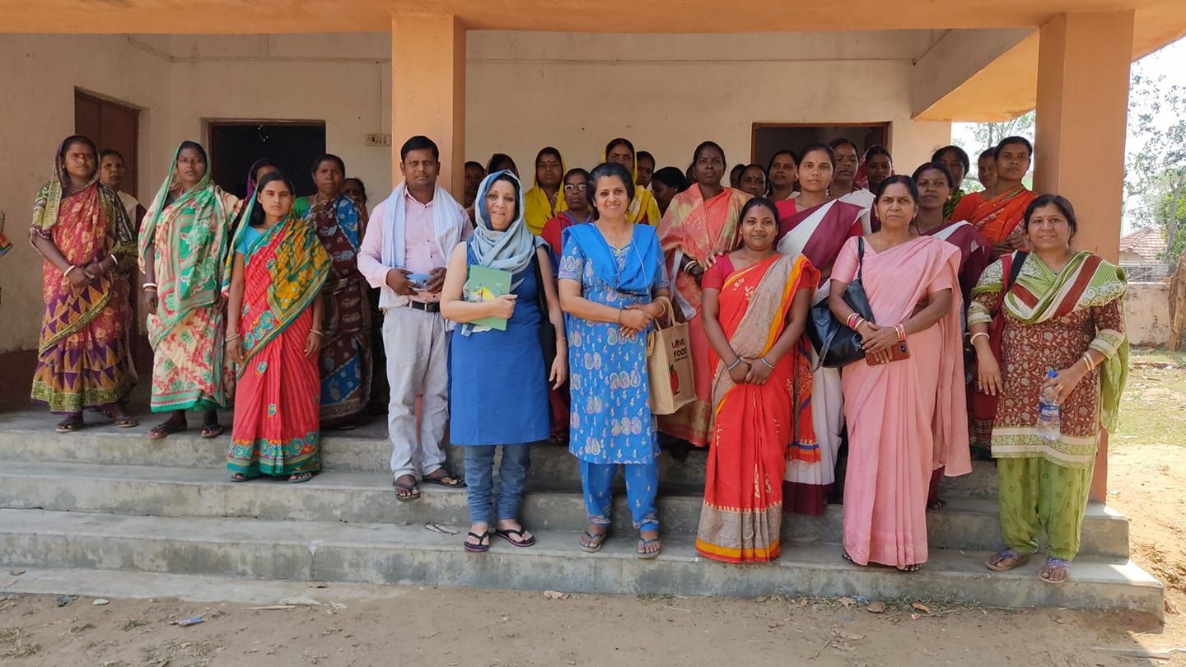

Badlao Foundation contacted SAFP to empower its gender strategy. This foundation works with the vulnerable people in Santhal parganas in Jharkhand. In particular their work with women of the Santhal and Paharia (PGT) tribal group has made sustainable livelihoods possible for women in groups and individual level. SAFP team comprising of Ms Arundhati Roy Chaudhary and Dr Bhardwaj visited Badlao foundation field areas in March 2022 to understand how the two organizations could merge their agendas together. Badlao Foundation has already registered Mutual Benefit Trust (MBT) of women in Jamtara and Godda districts of Jharkhand. SAFP suggested that Badlao Foundation strengthen the women organized in livelihood teams to manage the infrastructure in groups. This way the MBT of the organization could use to reduce gender resource gap for themselves as well as their own communities. SAFP and Badlao Foundation have developed plans to further the empowerment of the MBT. On their return SAFP submitted two concept notes to Badloa foundation for partnership based work for the future.

**Contribution to ongoing surveys**

The Vedica Women's Alliance conducted a survey on women's experiences at the workplace to understand factors that contribute to their success and advancement to leadership positions. Through this survey, the study investigated what makes a workplace favourable for women. SAFP circulated the survey form to its members requesting them to respond to the online survey. This activity as undertaken as a task among others to follow up on SAFP interest in watching the declining workforce participation of women in india.

Input to the discourse on housing by contributing to the UN Right to adequate housing report

The thematic reports of the Special Rapporteur on the right to adequate housing, Mr. Balakrishnan Rajagopal, to the General Assembly in 2021 and to the Human Rights Council in 2021 required information on state of affairs on the issue of discrimination in relation to the right to adequate housing, including the impact of spatial segregation in urban or rural-urban environments on the enjoyment of human rights. SAFP has been a member of an international housing and land Rights network for two decades. It understands that the spatial segregation can be understood as the imposed or preferred separation of groups of people in a particular territory by lines of race, caste, ethnicity, language, religion or income status. Spatial, including residential segregation can have different forms depending on the territorial, cultural or historical context and is often characterized by forms of economic and social exclusion, inequity and spatial disparity in access to infrastructure, services and livelihood opportunities. The focus of the report was to identify contemporary segregation that affect the right to adequate housing, to highlight good practices in the prevention of discrimination and segregation and to provide guidance to States on how they can ensure their human rights obligations in relation to non-discrimination and the right to adequate housing. HIC acknowledged that it received inputs from SAFP from India besides getting other NGOs to respond from Angola (Development Workshop Angola), Argentina (CISCSA and Movement of Occupants and Tenants of Argentina) and Mexico (Community Cooperation of Mexico and HIC-America Latina). SAFPs contribution was based on the work of its constituents in Delhi and Mumbai. The constituents were youth leaving care who had face unprecedented difficulties during the lock down by sudden closure of institutions that housed these orphans in hostels. The solution was to develop ask for youth leaving care in a long-term perspective.

**Club House**

The club house members kept trying to meet but Corona got them not meeting this entire year. The what’s app group of the club was still active and this was especially useful when the second wave raged the nation as well as Delhi. Ms Manu Tyagi Baijalvan began counselling services and reached out to different families in distress during the second wave. Soon it was realized that much more needed to be done. She then began her voluntary group called Kritagyata to help covid families in distress. Different club house members volunteered through this new platform to reach help such as oxygen, medicines, blood, ration and money during the second wave of covid 19.

**Work with Apna Ghar Inc.**

Apna Ghar is a registered charity based in Chicago that has established a shelter service for battered women. Dr Bhardwaj volunteered with Apna Ghar to provide strategic input to the development of a financial awareness manual that was being developed as a resource for the women Apna Ghar served. The manual itself was developed by Price Water House Cooper and handed to Apna Ghar for whetting. The constituents from south Asia are sent to Apna Ghar and often they were nowhere else go back to but the home where there is domestic abuse. Empowering the women with financial management and skill building thus is a strategy for the organization but most volunteers in Apna Ghar themselves had less financial management skill and being mostly American citizens, they required a perspective that was culturally different. SAFP experience of cultural ethos of women from South Asia came in handy in this situation.

**Advocacy For Care Leavers**

A support group based in Sunny Vale California called a Future For every Child, offered age sensitive skilling for children nad youth in difficult circumstances. The leader of this group called Gita, raised direct funding through one-on-one appeals with Individuals in families who had adopted children from India. These families were well to do Americans who had a sensitivity to children who were raised and not as fortunate to be adopted. SAFP contacted this network in the bid to source resources for the Youth Leaving Care network led by Mr Aditya Yatri. A number of tele and virtual meetings were held in San Jose in the month of August 2021 to take this issue ahead. The group later shared that they were largely fund raising for children who were still in Child Care Institutions (CCI) between the age of 16 and 18 and would support those children if a relationship of trust developed between the donor and the done. This collective was supporting a consortium of CCIs and therefore a support directly to the YLCA did not seem feasible.

**Planning Ahead**

The year ahead will carry forward activities on safeguarding vulnerable communities that SAFP was able to reach out in this year. Research on youth and development is planned to develop strategies for youth work, to capture work done through the year. Mr Rajesh Upadhyay developed concept notes for Women Resource Enterprize Zones for which he trained groups led by Ms Manu and Ms Rakhi to develop such zones within their sphere of influence.

**Chapter 5 SAFP Collaborators and people**

**SAFP Board of Trustees 2021-2022**

President: Manu Tyagi Baijalvan

Trustee: Ms Sharmila Mahajhan

Founder: Dr Shivani Bhardwaj

**SAFP Team**

Ms. Pranjali Malhotra Executive Director SAFP India

Ms Vandana Mahajan Gender Equality Advisor

Ms. Sunita Gupta Kotnala Advisor SAFP

Ms Seema Jay Kumar Advisor Mental Health

Ms Arundhuti RoyChaudhuri Advisor Child Rights

Mr Rajesh Upadhyaya Advisor Workers issues

Mr Ashok Bharti – Consultant Fund Raising

Mr Rahul Bannerjee, Ms Deepika Nair – Consultants for Karuna Evaluators

**SAFP Associates**

Dr. Sudeshna Roy – Research Associate

Mr Imran Khan – SAFP Youth Associate

Ms Rakhee Gupta – Women Rights Associate

Mr Aditya Yatri – Lead Youth Care Leavers Association

Ms Neha Jitendra – Entrepreneur Associate

Ms Wasima Akhtari – Intern Action Aid Research project

Ms Archana Meena – Intern Girls Aspire Project

**Collaboration with Partners:**  Nirmana, RDAMA, NACDOR, NALR, Project Purkul, Saheli Trust and Badlao Foundation